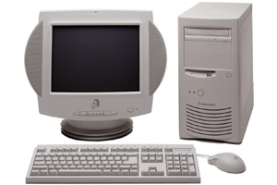
- 300MHz Intel Pentium® II Processor with MMX™ technology
- 512 KB L2 cache
- 8.4 GB hard disk drive
- 64 MB SyncDRAM upgradable to 256 MB
- 32X maximum, variable speed
- CD-ROM with up to 4800 KBps transfer rate
- 3.5", 1.44 MB diskette drive
- 3D AGP graphics/video accelerator with 2 MB Video RAM
- SVGA Video Resolution output up to 1600 x 1200
- 56 Kbps capable modem
- Fax system sends and receives faxes at speeds up to 14.4 Kbps
- Internet-ready with multiple access options
- 3-D Stereo Sound
- Keyboard
- Two-button mouse
- 3 Expansion Slots (2 PCI, 1 ISA)
- 5 Device Bays
- Ports include: Serial, ECPP, USB, Mouse, Keyboard, Game/MIDI and VGA

- Windows 98 - Word 97 - Works version 4.5 for Windows 95 -Encarta 98 KiddoNet - Intuit Quicken Basic 98 and Online Financial - MGI Photosuite Microsoft NetMeeting - Iris AntiVirus - CyberWarner - CyberCoach -CyberTrio

