Facial Image Modification
Jason Pinto
Advisor: Henry Schneiderman

Abstract

This thesis presents an automated process that takes a single photograph of a face and attempts to modify it realistically. This process finds feature locations (i.e. nose, mouth, eyes, etc.) by extracting them from a facial image, using the CMU face detector, and uses this information and other similar two-dimensional information to realistically modify a subsection of the image. Two characteristics in particular were explored: adding an earring to an earlobe and adding a tattoo to a cheek or forehead. While this investigation was restricted to these two specific cases, the basis for these types of modifications can be applied to any other type of similar modification.

1 Introduction

Digitally altered pictures can be found in almost any form of media distributed today. Everything from airbrushing out wrinkles from an actresses face on a magazine cover, to adding a spaceship into the background of a Sci-Fi film is painstakingly done by hand. The purpose of this thesis is to explore the feasibility of trying to automate this process. There are two major hurdles that must be overcome before this is possible. The first hurdle is having a way to detect key features within an image to obtain an understanding of the composition within the image. The second hurdle is to use this information to modify the existing image in order to produce realistic results.
As inroads are made in the areas of computer vision and image based rendering, the first hurdle is becoming more and more attainable. It is this second hurdle that concerns this thesis. The development of the CMU face detector setup a context where this can be done by providing a fairly large and interesting group of images where generalized features can be identified. It is the purpose of this paper to examine a process whereby a single facial image can be run through the CMU face detector to obtain key feature locations and then, based upon these locations, modify the face in a realistic manner. To reduce the size of the investigation, the method in this paper considers only two categories of facial image manipulation: total replacement and texture replacement.




Figure 1 Example of Total Replacement using an earring, Before (above) and After (below)

Total replacement takes an input facial image and an object or feature that can be added to the face and adds it to the image such that it totally obscures a subsection of it. Texture replacement is very similar to total replacement in that it requires a new object to add to the facial image, but instead of replacing an entire section of the original face, only a range of the frequencies from a subsection of the original image are replaced with frequencies from a similar range from the new object. Except for the final compositing step, both of these types of modification utilize the same steps. Both require that a collection or gallery of possible objects that can be added to a face be generated first. Also, in order for the results to look realistic, both types need the facial image and the image of the object be matched prior to the composite.
Realism in generated images is one of the hardest and most sought after attributes in computer graphics today. By trying to produce a new image from existing real images this problem gets slightly easier because both of the images used in the process are real, but in order for the final combination of the two to appear real the attributes of one image must match the attributes of the other. The key attributes that have to be matched to maintain realism are position, proportion, perspective, texture, lighting, blur and context. The first three attributes are matched using the information garnered from the feature locations. Texture is matched by using the texture replacement type for objects that require the textures between the face and object to blend. Context is matched by the fact that this system is only using facial images and objects that can be added to faces. Finally, lighting and focus are matched by trying best guess estimates and common sense rules.
This paper goes through the procedure necessary to prepare the gallery of objects before they can be used in the compositing process. Then it discusses the processes that were formulated to try and match the original face with the new object being added. Finally, it goes over how the matched images are composited together.

2 Generating an Object Gallery

The purpose of the object gallery is to provide a choice of images with known dimensions and properties that can be added to the input image into the automated process. For total replacement the process uses a gallery consisting of earrings, while for texture replacement the process uses a gallery consisting of tattoos. Each object in the gallery needs to be prepared such that two properties are known prior to execution: the size of the object, and also, the segmentation of the object from the background.
The procedure to prepare an object for the object gallery consists of two steps: segmenting the object from the background so as to generate a transparency mask or alpha channel, as well as, to develop a size metric for the object based upon facial features. Due to the fact that creating an alpha channel is an underspecified problem, the segmentation needs to be generated by hand [15]. The best way found to do this is to use a program like Photoshop and use the selection tool to select the parts that need to be opaque and deselecting the parts that need to be transparent. This selection can then be saved as a separate transparency, or alpha, channel. After the alpha channel is generated a scale metric has to be assigned to the object. This scale factor is required so that the automated process knows how large the object is relative to a set of facial features. Using this factor the process can scale the object based upon the locations of the features in the input image. For example, to calculated the scale factor for a nose ring a constant can be determined based upon the location of the nose, the tip of the nose, and an eye. In general, only two points are needed for this scale factor, but usually the more there are the better.


Figure 2 Example of an Earring (left) and the Alpha Channel of the Earring (right)

3 Matching Object and Facial Images

In order for the final image to appear realistic the lighting and clarity of the facial image and the object needs to be matched before they can be composited. In the case of matching lighting, two techniques are used. The first technique works on black and white images and tries to match the overall brightness of the images by looking at the histograms for the object and the face. The second technique works for both black and white and color images and uses a best guess approach. This approach entails flipping the object being added based upon where the ear is located within the image to try and match what the most probable lighting would be for that location. In the case of matching clarity, a technique is used to try and match the blur of the object by comparing it to the local blur in the facial image. This technique looks promising, but extensive tests are still yet to be done.

3.1 Lighting Techniques

Inverse lighting in general is a fairly hard problem and only now are algorithms being developed to calculate it given camera position and three-dimensional information of the objects in the input image [5]. Finding the lighting for a facial image, especially without having any camera or three-dimensional information, is even more difficult and might even be impossible. To get around this fact, this process tries to use a best guess approach to matching the lighting. First, it tries to match the intensity of the two images. For black and white pictures this means matching the intensity histogram of one to the other. Then using assumptions about the picture, the locations of the highlights and shadows of the new object are predicted using information from the facial image.
The primary technique to match lighting in black and white images is histogram matching. Histogram matching consists of taking the intensity histogram of the face and of the object and then modifying the objects histogram so that it falls within the same range as the face’s histogram. In particular, two rules seem to produce the best results. The first is to scale the object’s histogram to within ten percent of the highest and lowest value in the face’s histogram. This works best since it ignores any single pixel or small group of pixels that are outliers in the face’s histogram. The second rule is used if the object being added has any bright highlights. In this case, the brightest pixel on the face is found and the highest value of the object histogram is scaled to this value. This rule uses the fact that for most faces under direct lighting there is at least one spot that has a caustic or bright spot.

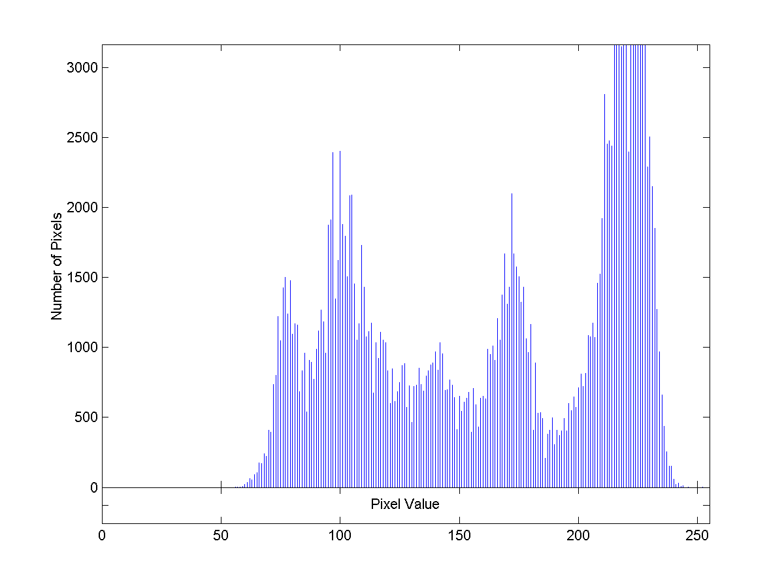
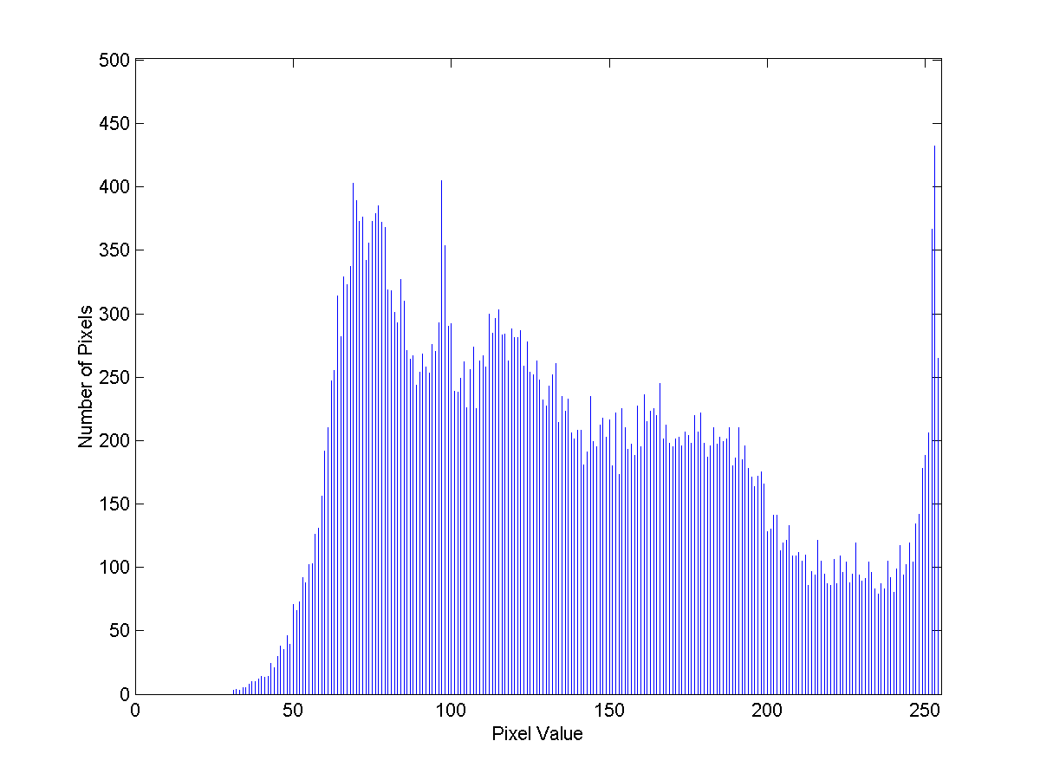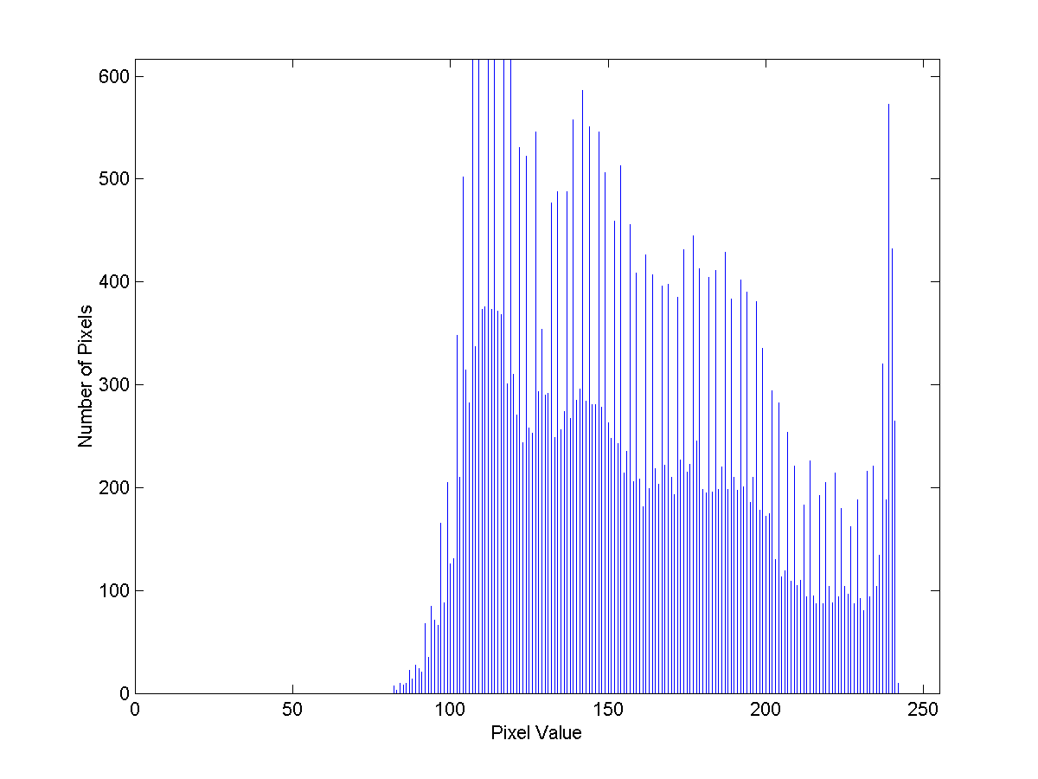
Figure 3 Histogram of a Facial Image (top), Histogram of an Earring (middle), Histogram of the same Earring after being matched to the Facial Image (bottom).

For all images, a location based method is used to try and match lighting. This approach uses the simple idea that, in general, when a photograph is taken of a face, the lighting is straight on and slightly from above. Therefore, if the object is being added to the left of the center line in the facial image, the shadows are more likely to be on the outside edge or left edge of the image and the highlights are more likely to be closer to the center line of the image. Using this assumption, the object being added can be positioned so that the shadows are more to the outside and the highlights are more towards the inside of the image. This approach is fairly simple and works on small objects like earrings, but will not work on objects much larger in size.


Figure 4 Example of Earring with Highlights on the Right and Shadows on the Left (left) and vice versa (right)

3.2 Blur Correction

The next step in trying to maintain realism between the facial and object images is to match the clarity of the two. This requires finding how blurry the facial image is in the local area around where the modification will take place and then to blur the object down to this level. Since blur is the loss of high frequency content in an image, this effectively means trying to match the level of high frequency loss in one with the other. The high frequency content is calculated by taking the average power spectral density of both images over the local area where the composite will occur and then calculating the average power over a mid to high range of frequencies. This average is then compared between the face and the object to come up with a ratio. This ratio is then run through a previously calculated table to try and establish which object is more blurry and by how much.
This procedure is currently only being tested for the total replacement category and specifically in adding earrings to ears. For this case, the average of the mid to high range of frequencies is taken over a subsection of the earring and also over the ear in the facial image. These averages are then divided to create a ratio. Figure 5 displays a graph of a single range of ratios for different levels of blur. For the most part, the graph tends towards a linear progression. Also of note is that if the ear or the earring is more blurry than the other, the curve in the graph shifts up or down. Figure 6 shows the results from seven ear/earring combinations. The majority of these combinations fall with in a small area, but there have been no convincing arguments made as to why three of these combinations are much higher than this range. More work needs to be done in this area to find out why these outliers exist and what would be a feasible range in which to fill the blur matching table.

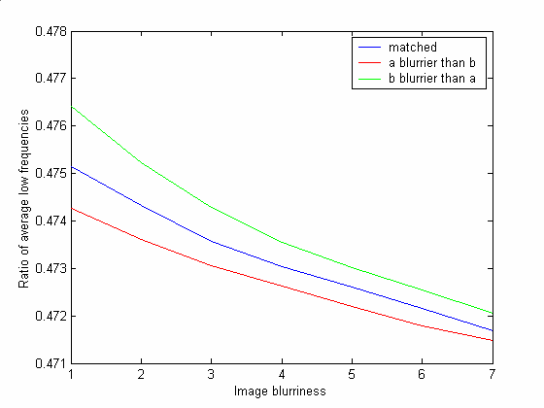
Figure 5 Results of Relative Blur Analysis for a single image at seven different levels of blur. The red and green lines represent unmatched Blur Ratios.
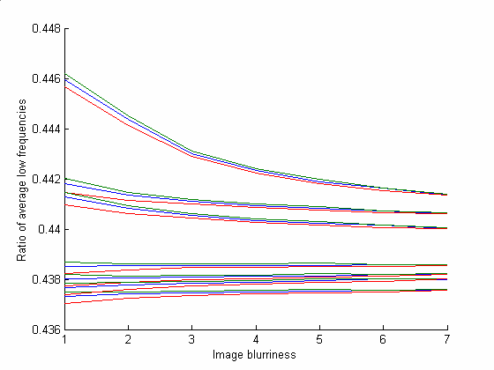
Figure 6 Results of Relative Blur Analysis for seven images at seven different levels of blur. The red and green lines represent unmatched Blur Ratios.

4 Compositing Technique

The procedure to add a characteristic to a facial image can be broken up into three parts. The first consists of finding the position, rotation, and scale of the object relative to the face. The second step involves transforming the object to match the attributes calculated. Finally, the last step entails compositing the object with the face.

4.1 Position, Rotation, Scaling

To find the position, rotation, and scale of any object that is going to be added to a facial image, a basis for each metric has to be made in terms of locations of facial characteristics. The most straightforward way of finding position and scale is to take a weighted average of salient facial feature locations where the weighting adds up to one. Rotation is a bit harder, but intuitively it is similar. Rather than rotating the object to the face, it is often easier to try and rotate the face to a known rotation, then perform the composite, and then rotate the image back. Finding the rotation of the face to a known reference frame can be accomplished by using spatial registration on the facial feature locations. Spatial registration attempts to find the rotation where the landmarks in one image best match the landmarks in another image. In this way the rotation of the original facial image can be rotated to a known location and then the position and scale can be determined from a weighted average from the new rotated features.
For example, to add a nose ring to a face the process first runs spatial registration so that the face is fairly upright. Then the position can be found by finding a weighted average using the location of the base of the nose, the tip of the nose, and also the right eye. To obtain a final position of the nose ring on the side of the nose, the best weighting will give a higher weight to the x pixel locations of the base of the nose and the nose tip, while assigning less to the eye. Similarly, the weighting in the y direction will give the nose tip a higher weighting than either the base of the nose or the eye. Therefore, given the face in Figure 7, the nose ring coordinates nrx and nry can be defined as:

$$\begin{aligned}\text{nrx}=\text{xw}1×\text{ex}+\text{xw}2×\text{ntx}+\text{xw}3×\text{nx} \\ \text{nry}=\text{yw}1×\text{ey}+\text{yw}2×\text{nty}+\text{yw}3×\text{ny}\end{aligned}$$

where

$$\begin{aligned}\text{xw}1+\text{xw}2+\text{xw}3=1 \\ \text{yw}1+\text{yw}2+\text{yw}3=1\end{aligned}$$

After the position is calculated, the object can be scaled using the information that was generated when it was added to the gallery. Finally, using all this information, the object can be composited.

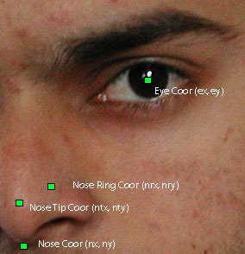
Figure 7 Example of Object Positioning

4.2 Composite

The compositing step of the process entails combining the two images together in such a way that there is no clear edge where one image begins and the other ends. The most effective way to do this is by using an object that uses an alpha channel to denote transparency. An alpha channel is much like a regular color channel, but rather than describing the range within a channel of color it describes the opacity of the image. The final image is calculated by multiplying the inverse of the alpha channel with the original facial image and adding that result to the multiplication of the alpha channel with the new object. By tapering off the values of the alpha channel around the edges of the new object the result will blend together the edge with the existing facial image and no visible defects or edges will be present.
Compositing for texture replacement has an extra step in the final stage. A subsection of frequencies from the input image and the object are combined prior to the final composite. This step helps to maintain texture continuity for objects like tattoos. In particular, in order to maintain skin texture, the high frequencies from the facial image and the tattoo are added and normalized. Two problems are evident, however. The first is that there is no constant threshold to determine the cutoff frequency needed for the combination since skin texture varies from face to face. The second problem is that for a tattoo to appear realistic, it has to curve as the skin curves, but this process recognizes curvature as skin texture. Skin curvature requires three-dimensional information, and due to the nature of the problem being a single image as input, three-dimensional information can not be calculated. As a result of these problems, texture replacement seems infeasible with only a single image input.

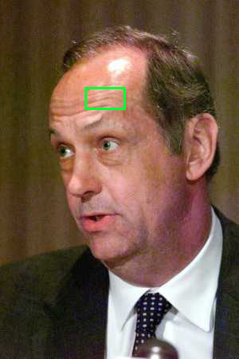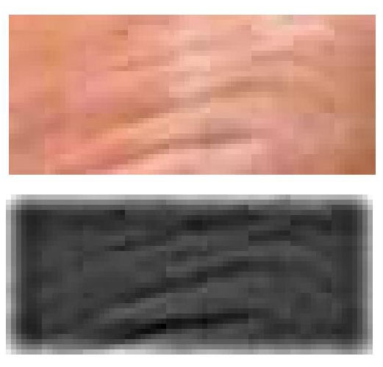
Figure 8 Example of Curvature recognized as Texture. Original Picture (left), Forehead (top), Texture Filtered from Forehead (bottom).

5 Conclusion and Future Work

This paper outlines an approach that can be used to modify a single facial image. For the most part, this process requires assumptions be made about the content of the input and therefore becomes infeasible if they are broken. The obvious next step is to move into the three-dimensional realm. By gaining this information, better estimates of position, texture, and lighting can be made and will reduce the need for many of the assumptions that must be made in the two-dimensional case.

References

[1] Debevec, P., Yu, Y., Borshukov, G. Efficient View-Dependent Image-Based Rendering with Projective Texture-Mapping. UC Berkeley technical report #UCB//CSD-981003.
[2] Ramamoorthi, R., Hanrahan, P. A Signal-Processing Framework for Inverse Rendering. Computer Graphics (SIGGRAPH), 2001.
[3] Debevec, P. Rendering Synthetic Objects into Real Scenes: Bridging Traditional and Image-based Graphics with Global Illumination and High Dynamic Range Photography. SIGGRAPH 98 Conference Proceedings, 1998.
[4] Debevec, P., Camillo, J., Malik, J. Modeling and Rendering Architecture from Photographs: A Hybrid Geometry and Image-Based Approach. SIGGRAPH '96, August 1996.
[5] Yu, Y., Debevec, P., Malik, J. Inverse Global Illumination: Recovering Reflectance Models of Real Scenes from Photographs. SIGGRAPH 99, August 1999.
[6] Lagendijk, R., Biemond, J. Basic Methods for Image Restoration and Identification. February 1999.
[7] Blanz, V., Vetter, T. A Morphable Model For The Synthesis Of 3D Faces. SIGGRAPH 99, pages 187-194, 1999.
[8] Ramamoorthi, R., Hanrahan, P. Analysis of Planar Light Fields From Homogeneous Convex Curved Surfaces Under Distant Illumination.
[9] Kundur, D., Hatzinakos, D. Blind Image Deconvolution: An Algorithmic Approach to Practical Image Restoration. IEEE Signal Processing Mag., vol. 13, pp. 43-64, May 1996.
[10] Poulin, P, Fournier A. Lights from Highlights and Shadows. Computer Graphics (SIGGRAPH), vol. 25, pp. 31-38, March 1992.
[11] Greenberg, D., Torrance, K., Shirley, P., et. al. A Framework for Realistic Image Synthesis. SIGGRAPH 97 Conference Proceedings, pp. 447-494, August 1997.
[12] Ramasubramanian, M., Pattanaik, S., Greenberg, D. A Perceptually Based Physical Error Metric for Realistic Image Synthesis. Computer Graphics (SIGGRAPH 99), pp. 73-82, 1999.
[13] Oliveria, M., Bishop, G. Image-Based Objects. SIGGRAPH 99 Conference Proceedings, pp. 191-198, 1999.
[14] Oliveria, M., Bishop, G. Dynamic Shading in Image-Based Rendering. UNC Computer Science Technical Report TR98-023, 1998.
[15] Smith, A. Alpha and the History of Digital Compositing. Technical Memo 7, Microsoft Corporation, August 1995.
[16] Chen, S., Williams, L. View Interpolation for Image Synthesis. Computer Graphics (SIGGRAPH 93), vol. 27, pp. 279-288, August 1993.
[17] Wolberg, G. Digital Image Warping. IEEE Computer Society Press, 1990.
[18] Sonka, M., Hlavac, V., Boyle, R. Image Processing, Analysis, and Machine Vision. Brooks/Cole Publishing Company. 1999.

