Improving story choice in a reading tutor that listens
Greg Aist1 and Jack Mostow1
1 Project LISTEN, 4215 Newell-Simon Hall, Carnegie Mellon University,
Pittsburgh, Pennsylvania 15213, USA
{aist, mostow}@cs.cmu.edu http://www.cs.cmu.edu/~listen

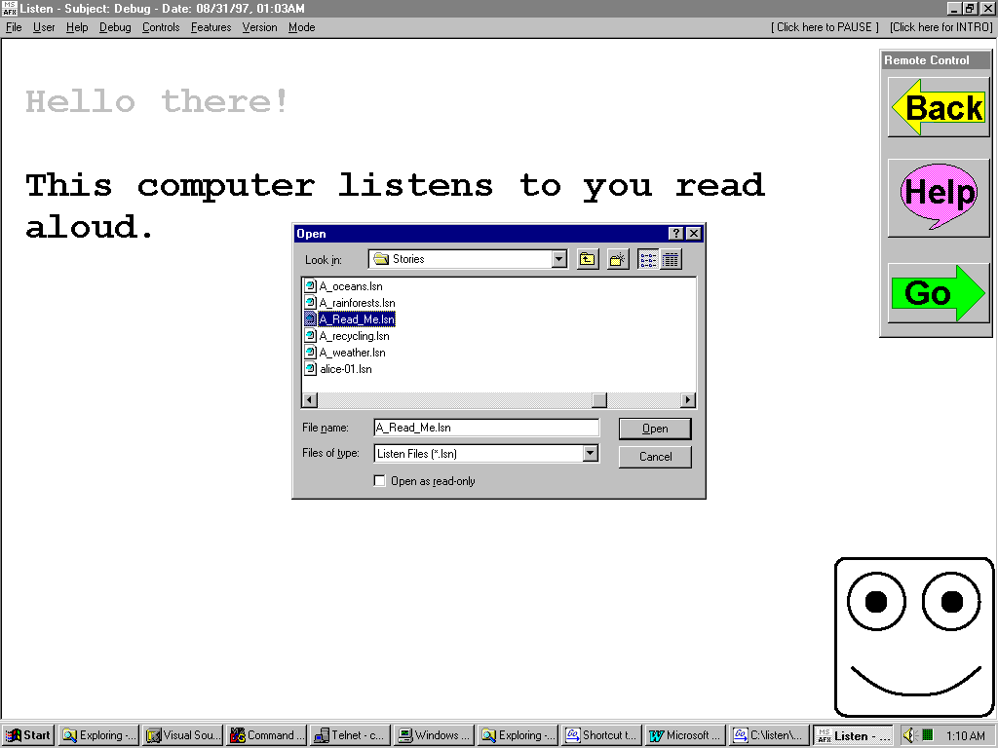
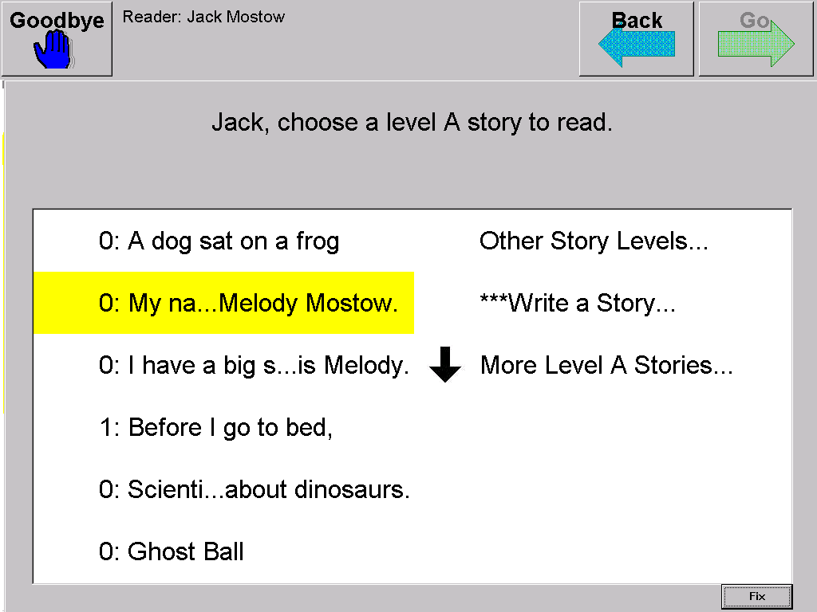
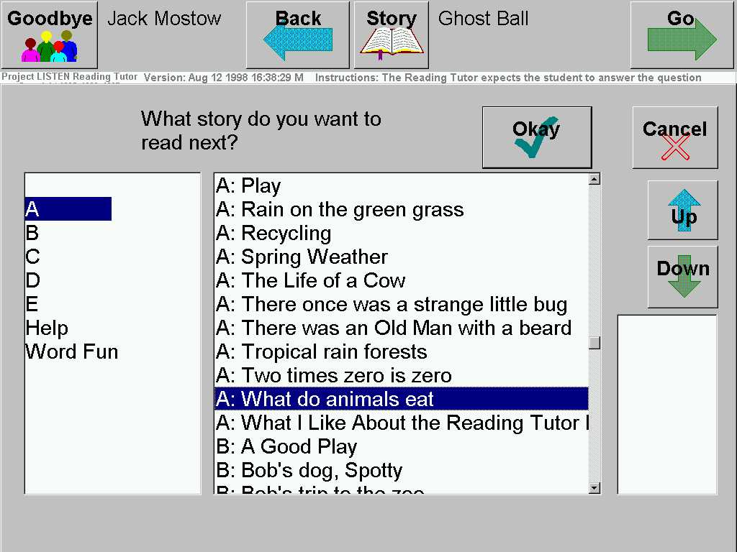
This abstract summarizes how we improved task choice – picking a story to read – in successive versions of a Reading Tutor that listens to elementary students read aloud. We wanted to motivate children to spend time on the Reading Tutor by giving them some choice in what to read, without spending too much time picking stories. We also wanted them to read plenty of new text, so as to build vocabulary and decoding skills.
1996: adult-assisted picker 1998: 2-click picker 1999: 1-click picker
The 1996 Tutor was supervised one-on-one by a school aide, who took ~3 minutes in a generic file picker to help pick stories. To include time spent browsing titles or picking the wrong story by mistake, we measured choice time from the last sentence read in the previous story to the second sentence read in the next story. The mix of new and previously read stories was reflected in the fraction of new sentences, namely ~43%.
Figure
Figure 1
The 1998 Tutor aimed at independent classroom use by possible non-readers. It gave spoken prompts on what to do, and read a story title aloud (along with a difficulty estimate based on the percentage of new words) if the child clicked on it. The child clicked Okay to pick that story. To pick again, the kid could click on Story, or finish the story and answer 1-2 multiple-choice questions like “Was that story easy, hard, or just right?” (Most stories were not finished.) It took ~2 minutes (including questions) to pick stories, with 59% new text – but some children kept rereading the same stories.
To increase this percentage, the 1999 Tutor took turns picking stories, selecting unread stories at the child’s reading level (estimated based on assisted oral reading rate). For the child’s turn, the simplified “one-click picker” read the list of titles aloud. As soon as a child clicked on a title, the Reading Tutor displayed that story to read aloud. To pick some other story, the child could click Back to return to the story picker, which thus replaced 2-click “select and confirm” with “select, then optionally repent.” Picking now took 26 seconds, with 66% new text: significantly more than in 1998, p=.003.

