15-104 Introduction to Computing for Creative Practice – FALL 2024

NAME: ENTER YOUR NAME HERE

ANDREW ID: ENTER YOUR ANDREW ID HERE

SECTION: ENTER YOUR SECTION LETTER HERE (A-E)

CONCEPTS QUESTIONS 12

Enter your answers to each of these questions in the space provided. Do not use online tools (including AI tools). Do not consult with other students when answering these questions. The information you fill in should be your work and only your work.

- Consider the following p5.js function:
def function mystery(n) {
if (n == 0) return 1;
else return 3 * mystery(n - 1);
}
Show how the value of mystery(5) is computed, step by step, like factorial was shown in class. The first two steps are given for you.
YOUR ANSWER:
mystery(5) = 3 * mystery(4)
mystery(4) = 3 * mystery(3)

- Based on your trace from problem #1, state in English what this function is computing with respect to n.

YOUR ANSWER:

- Write a function mystery2 in p5.js that computes and returns the same value as the mystery function in problem #1 using a loop instead of recursion. Do not use any predefined functions in p5.js.
YOUR ANSWER:

- We wish to draw a cube of size 100 in 3D space on a 400 X 400 canvas such that its front face (the side we see with the default camera) is on the z = 0 plane. In the pictures below, we show the z = 0 plane with a grid to help you orient yourself.

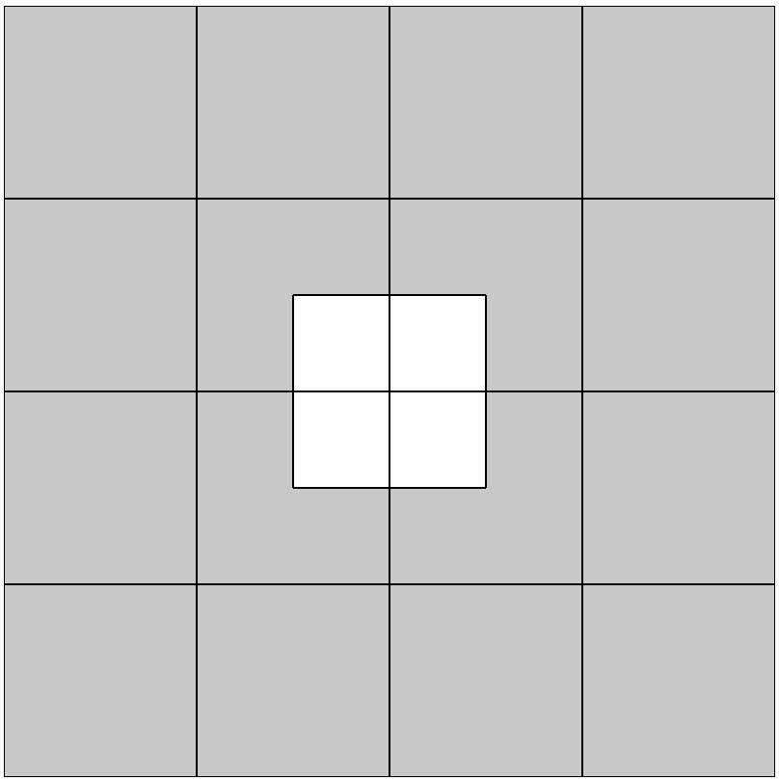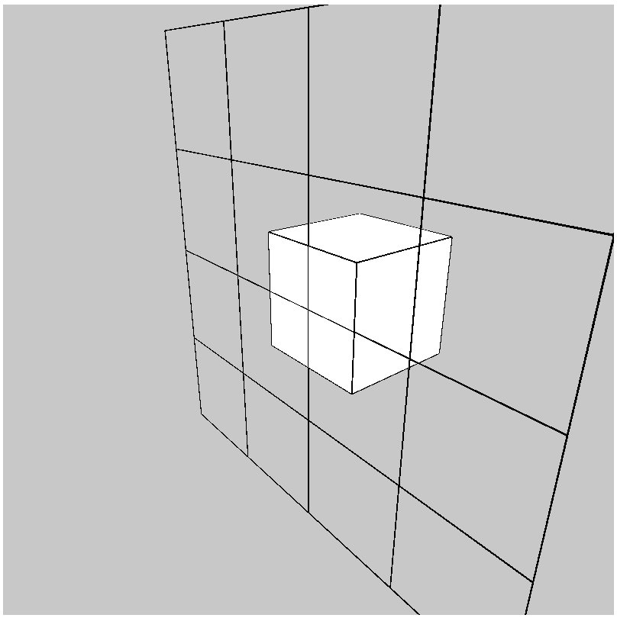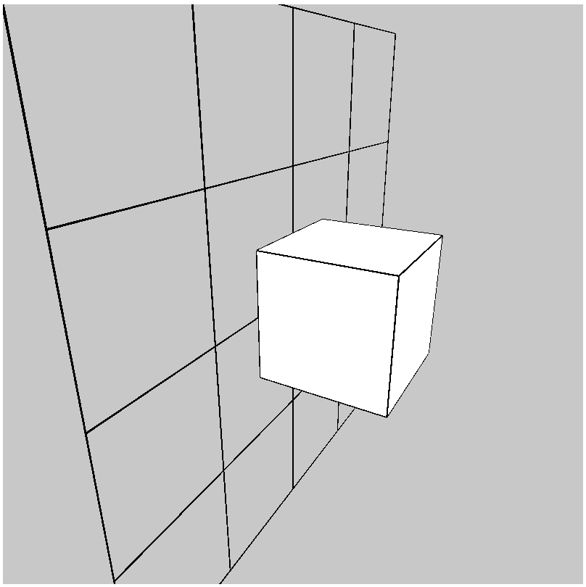
left picture: View of cube from the front
middle picture: View of cube from in front of the z=0 plane from the side
right picture: View of cube from behind the z=0 plane from the side

Complete the missing 2 instructions so that we see the pictures above.
function setup() {
createCanvas(400, 400, WEBGL);
}
function draw() {
background(200);
orbitControl();
push();
// MISSING 2 INSTRUCTIONS
pop();
}

YOUR ANSWER:

