|  |
| --- |
| 15-110 Recitation 10 |

# **Recap**

* Concurrency
* MapReduce
* Pipelining
* Internet

# 

# **Reminders**

* Test 4 tomorrow! (11/6)
* HW5 due next Wednesday (11/11) (there is no check5)

|  |
| --- |
| Problems |

# **MERGESORT CONCURRENCY**

What steps can be done in parallel?

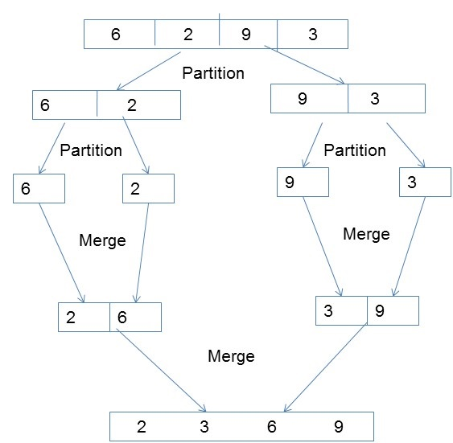

# **MAPREDUCE**

Suppose we make a mapReduce function to count the number of files that have an even number of even numbers. Define the mapper, collector, reducer function.

Answer

# **LAUNDRY PIPELINING**

Similar to the laundry problem in lecture: say we have a system where we need to wash, dry, iron, and fold each load of laundry. Each stage takes 30 minutes, and we have access to 4 washers, 2 dryers, 2 ironing stations, and 4 folding stations.

Without any pipelining, how many loads of laundry can you do in 3 hours?

Answer

With pipelining, how many loads of laundry can you do in 3 hours?

Answer

# **INTERNET TRUE/FALSE**

The internet is governed by a series of protocols, HTTPS is one of them.

Answer

The net neutrality debate surrounds whether internet users should be able to create biased content and share it on public internet forums.

Answer

There are an infinite number of IP addresses

Answer

IP addresses can be static or dynamic

Answer

All packets routed back to your computer from a website are guaranteed to be routed through the same wire.

Answer

The internet is built such that if some components go down, it can continue operating with no interruption.

Answer

# **OPEN OH**

Open OH time to ask questions about the topics covered in recitation.

# 