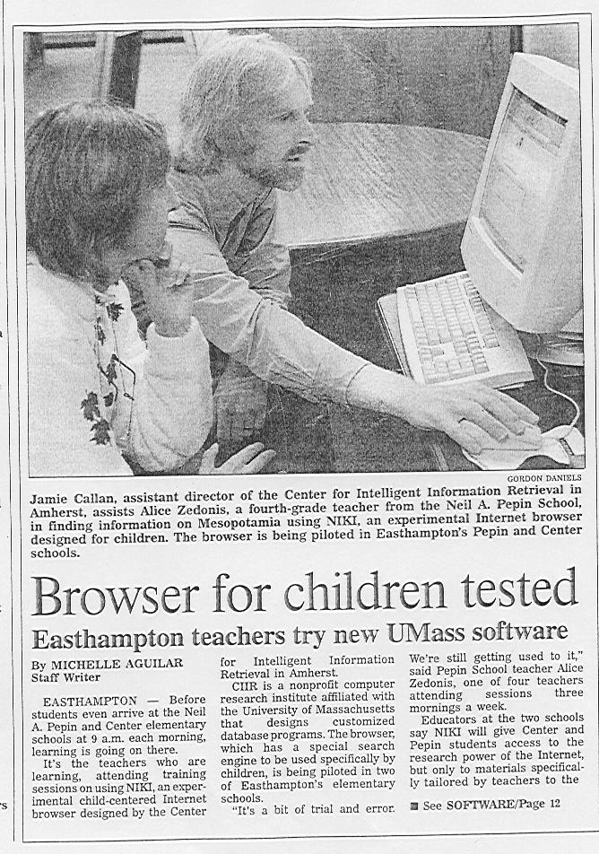
Daily Hampshire Gazette, Northampton, Massachusetts. October 17, 1998.
