Advanced BST Operations

Traversing Trees
One of the important operations on a BST is to find a way to traverse all the nodes in the tree. As we know traversing a linked list or array is easy. We just start from the first node and traverse linearly until we come to the end of the list. But, it is not so trivial in a BST. Consider the binary search tree
38
/ \
5 45
/ \ \
1 9 47
/ \ /
8 15 46
/
13
There are several methods of traversing trees. Among them are the inorder, preorder and postorder traversal of nodes. Each of these traversal algorithms visit every node of the BST in a particular order.
InOrderTraversal : The idea of inorder traversal is that we visit the nodes in the order left-root-right, meaning for any subtree in the path, left node must be visited first followed by root and right node.
- Left, Root, Right
- Prints the values in ascending order
In the above example, the in-order traversal is
1, 5, 8, 9, 13, 15, 38, 45, 46, 47
Inorder traversal is always symmetrical.
Implementation: The implementation of inorder traversal is fairly straightforward.
private void inorder(Node root){
if (root != null) {
inorder(root.leftChild);
// visit root;
inorder(root.rightChild);
}
PreOrderTraversal
- root, left, right
- processed as the node is visited
In the above example, the pre-order traversal is
38, 5, 1, 9, 8, 15, 13, 45, 47, 46
Imagine a car, which goes around a tree, starting with a root and keeping the tree on a left side.
PostOrderTraversal
- left, right, root
- node is not processed until the children are
In the above example, the post-order traversal is
1, 8, 13, 15, 9, 5, 46, 47, 45, 38
This picture demonstrates the order of node visitaion in postorder, preorder, and inorder traversals:
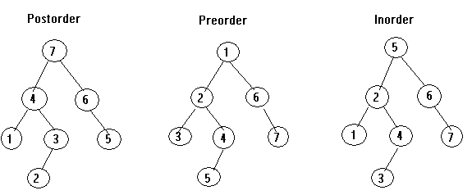
LevelOrderTraversal
- Processing nodes from top to bottom, left to right
In the above example, the level-order traversal is
38, 5, 45, 1, 9, 47, 8, 15, 46, 13
We can implement the level-order traversal using the API's LinkedList class.
There are number of other operations that can be performed on BSTs. Among them finding the height of a tree, depth of a node, counting the total nodes, computing the balance factor of a node is important.
Path from Node A to Node B
First we must define the notion of a path. We say there is a path from node A to node B if there is a (unique) way to get from A to B. The path length is defined as the number of edges in the path from A to B. Note that number of nodes is one more than the number of edges. The height of a tree is defined as the length of the longest path from root to any leaf node. Depth of a node is defined as the path length from root to node. The height of a node is defined as path length from node to the deepest leaf node in the tree.
Euler Tours:
The three common traversal algorithms can be represented as a single algorithm by assuming that we visit each node three times. An Euler tour is a walk around the perimeter of a binary tree where each edge is a wall, which you cannot cross. In this walk each node will be visited (touched) either on the left, or in the below, or on the right. For a left these three visits happen one right after the other, whereas for interior nodes that is not a case. The Euler tour in which we visit nodes on the left produces a preorder traversal. When we visit nodes from the below, we get an inorder traversal. And when we visit nodes on the right, we get a postorder traversal.
Exercise : Is it possible that the preorder traversal of a binary tree with more than one node visits the nodes in the same order as the postorder traversal?
Exercise: Draw a binary tree T such that : each node stores a single character , a preorder traversal of T yields BINARY, a postorder traversal of T yields NRYAIB
B
/
I
/ \
N A
/ \
R Y

Delete Operation
Algorithm: (two steps)
• 1. Find a node to be deleted (throw an exception otherwise)
• 2. Delete the node
Depending on where the node is found, we will consider three sub-cases: Deleting a leaf node, deleting a node with one child; and deleting an internal node( node with 2 children).
• node.left == null
- make a parent node point to a right child;
• node.right == null
- make a parent node point to a left child;
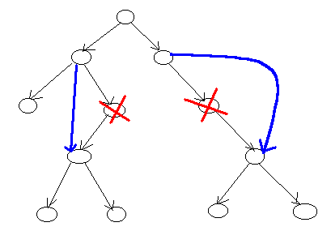
Deleting a Node with one child
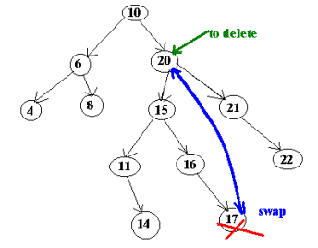
Deleting an internal Node
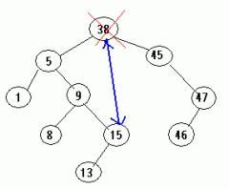
Deleting the root of the tree
Implementation (part I):
public void delete (Comparable d)
{
root = deleteHelper(root, d);
}
private BNode deleteHelper (BNode r, Comparable d)
{
if (r == null)
throw new RuntimeException("cannot delete.");
else
if (d.compareTo(r.data) < 0)
r.left = deleteHelper (r.left, d);
else
if (d.compareTo(r.data) > 0)
r.right = deleteHelper (r.right, d);
else
{
size--;
if (r.left == null)
return r.right;
else
if (r.right == null)
return r.left;
else
{
// to be continued...
}
}
return r;
}
Consider the binary search tree
38
/ \
5 45
/ \ \
1 9 47
/ \ /
8 15 46
/
13
and suppose we want to delete a node with the label 15. Here is a stack of recursive calls:
38.left = deleteHelper(5_node, 15)
5.right = deleteHelper(9_node, 15)
9.right = deleteHelper(15_node, 15)
deleteHelper(15_node, 15) returns 13_node
Because of the last two lines, the node 9 is be connected to 13, and the node 15 is deleted (since there is no references pointed to it).
• delete a node with TWO children
- find the rightmost node in the left subtree and swap data between these two nodes.
The rightmost node will be the node with the greatest value in the left subtree. Why do we need this node? One way of thinking about it is that you want to replace the node to be deleted with a node that has the biggest value in the left subtree. Alternatively, you can swap data between the node to be deleted and the leftmost node in the right subtree.
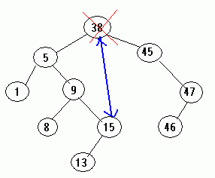
Implementation (part II):
r.data = getNode(r.left).data; // swap data
where
private BNode getNode(BNode r)
{
while (r.right != null) r = r.right;
return r;
}
-Note.A node to be _actually_ deleted can have a left subtree:
To delete 15 you need to go to 9 and change the right reference to 15's left reference.
Implementation (part III):
r.left = getLink(r.left); //why do we need an assignment here??
where
private BNode getLink(BNode r)
{
if (r.right != null)
r.right = getLink(r.right);
else
r = r.left;
return r;
}
Answer: Consider a tree
38
/ \
5 45
in which you want to delete 38. On the first step you will move 5 to 38 node
5
/ \
5 45
On the second step you will need to remove the left subtree. If you do not do the assignment you will never set a left reference to null.
Exercise : If you delete a node from a BST and then insert it back, will you change the shape of the tree?

Traversing Trees using the Iterator class
Iterator is the API interface. A class which implements Iterator should implement three methods
- boolean hasNext() - Returns true if the iteration has more elements.
- Object next() - Returns the next element in the iteration.
- void remove() - (optional operation) Removes from the underlying collection the last element returned by next().
We implement a preorder traversal by ading a new method iterator to the BSTree class. This method returns an iterator over the nodes of a binary tree in pre-order:
public Iterator iterator()
{
return new PreOrderIterator();
}
Class preOrderIterator is an inner private class of BSTree. This class implements the Iterator interface. We use the Stack as an intermediate storage:
private class PreOrderIterator implements Iterator
{
private Stack stk = new Stack();
// Construct the iterator.
public PreOrderIterator()
{
stk.push(root);
}
< ...skip...>
}
We implement next()
public Object next()
{
BNode cur = (BNode) stk.peek();
if(cur.left != null)
{
stk.push(cur.left);
}
else
{
//if a left child is null
BNode tmp = (BNode) stk.pop();
while(tmp.right == null)
{
if (stk.isEmpty()) return cur;
tmp = (BNode) stk.pop();
}
stk.push(tmp.right);
}
return cur;
}
Algorithm - If there is a left child, we push the child on a stack and return a parent node. If there is no left child, we check for a right child. If there is a right child, we push the right child on a stack and return a parent node. If there is no right child, we move back up the tree (while-loop) until we find a node with a right child.
Here is a stack after returning 38 and 5:
| | cur | | | |
|1 | <--- tmp | | | |
|5 | |5 |<--- tmp |9 |<--- tmp
|38| |38| |38|
---- ---- ----
We shall leave the method remove() unimplemented. Since a binary tree has a nonlinear structure, removing a node might cause the major tree rearrangement, which will lead to incorrect output from next():
public void remove()
{
throw new java.lang.UnsupportedOperationException();
}

