A Brief Synopsis of Kane’s Method

This paper is the result of my interest in multi-body dynamics and desire to increase my knowledge on the topic. My initial intentions were to teach myself Kane’s method (originally called Lagrange form of d’Alembert’s principle) for developing dynamical equations of motion and then prepare a lecture for class. As I started learning and applying the technique I realized that a small lecture would not be sufficient to teach the method and have time to get to some of the more interesting applications. In this paper I present a proof of Kane’s Method using the Principle of Virtual Work, a general procedure for developing equations of motion, and a few applications.
Essentially all methods for obtaining equations of motion are equivalent. However, the ease of use of the various methods differs; some are more suited for multibody dynamics than others. The Newton-Euler method is comprehensive in that a complete solution for all the forces and kinematic variables are obtained, but it is inefficient. Applying the Newton-Euler method requires that force and moment balances be applied for each body taking in consideration every interactive and constraint force. Therefore, the method is inefficient when only a few of the system’s forces need to be solved for.
Lagrange’s Equations provides a method for disregarding all interactive and constraint forces that do not perform work. The major disadvantage of this method is the need to differentiate scalar energy functions (kinetic and potential energy). This is not much of a problem for small multibody systems, but becomes an efficiency problem for large multibody systems.
Kane’s method offers the advantages of both the Newton-Euler and Lagrange methods without the disadvantages. With the use of generalized forces the need for examining interactive and constraint forces between bodies is eliminated. Since Kane’s method does not employ the use of energy functions, differentiating is not a problem. The differentiating required to compute velocities and accelerations can obtained through the use of algorithms based on vector products. Kane’s method provides an elegant means to develop the dynamics equations for multibody systems that lends itself to automated numerical computation. (Huston 1990)

Derivation of Kane’s Equations Using the Principle of Virtual Work
Consider an open-chain multibody system of N interconnected rigid bodies each subject to external and constraint forces. The external forces can be transformed into an equivalent force and torque (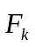 and 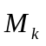) passing through 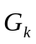, the mass center of the body k (k = 1,2…N). Similar to the external forces, the constraint forces may be written as 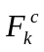and 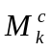. Using d’Alembert’s principle for the force equilibrium of body k, the following is obtained:
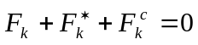
where 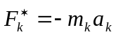is the inertia force of body k.

The concept of virtual work may be described as follows for a system of N particles with 3N degrees of freedom. The systems configuration can be described using q_{r} (r = 1,2,…3N) generalized coordinates with force components F₁, F₂,…, F_{3N} applied to the particles along the corresponding generalized coordinates. The virtual work is then defined as:
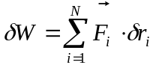
Where 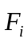 is the resultant force acting on the i^{th} particle and is the position vector of the particle in the inertial reference frame. 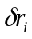 is the virtual displacement, which is imaginary in the sense that it is assumed to occur without the passage of time.

Now applying the concept of virtual work to our multibody system considering only the work due to the forces on the system we obtain:

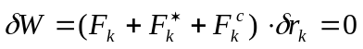 (k = 1,2,…,N)

The constraints that are commonly encountered are known as workless constraints so…

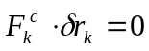

Which simplifies the virtual work equation to:

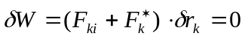 (k = 1,2,…,N)
or
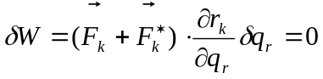 (r = 1,2,…,3N) *

The positions vector may also be written as:
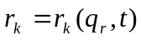
so
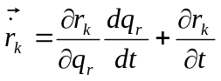

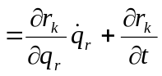
Taking the partial derivative of 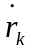with respect to 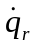 yields
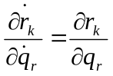
or
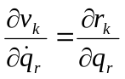
Since the virtual displacement 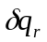is arbitrary without violating the constraints we can write * as:
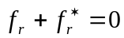
where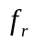 and 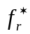 are the generalized active and inertia forces respectively and are defined as follows:
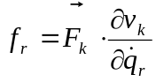
and
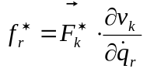
In a similar fashion it can be shown using virtual work that the moments can be written as:
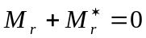
where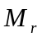 and 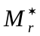 are the generalized active and inertia moments respectively and are defined as follows:
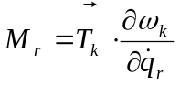
and
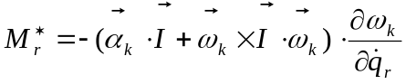
By superposition of the force and moment equations we arrive at Kane’s equations:
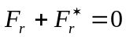
where
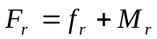
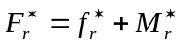
(Adapted from Amirouche 1992)

Notation

Notation that will be used throughout the rest of the paper:
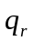 - generalized coordinate
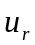 - generalized speed, typically equal to 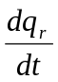
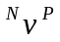 - velocity of P with respect to the Newtonian (inertial) reference frame
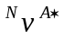 - velocity of the center of mass of body A
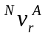 - partial velocity, equal to 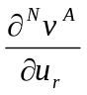
C_{n} or S_{n} – Cos(n) or Sin(n)

General Procedure for using Kane’s Method

1) Label important points (important points being defined as all center of mass locations, and locations of applied forces with the exception of conservative constraint forces).

2) Select generalized coordinates (q_{r}) and generalized speeds (u_{r}), then generate expressions for angular velocity and acceleration of all bodies and velocity and acceleration of the important points.

3) Construct a partial velocity table of the form:

Generalized Speeds ( u_{r} ) | 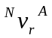 | 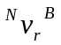 | 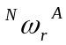 | 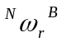
r = 1
r = 2
.  .  . | .  .  . | .  .  . | .  .  . | .  .  .

4) Fr + Fr* = 0

where the generalized active force, F_{r}, is defined as:
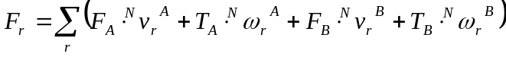
and the generalized inertia force, F_{r}*, is defined as:

5) Which can then be written in the form:

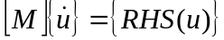
Applications
In this section of the paper I will step through some of the example problems I did to familiarize myself with Kane’s method. I started with simple two-dimensional problems that I could easily confirm the equations of motion using other methods. As I felt more comfortable with Kane’s method I moved onto 3D problems involving non-holonomic constraints. Presented here are a few of those problems, which demonstrate the subtleties of Kane’s method.

Problem 1
The first problem is a spring-mass-pendulum problem with frictionless sliding. This was problem is good for showing the general procedure of Kane’s method.
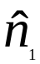
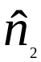
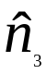
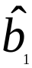
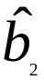
A
P
K
q₁
q₂
L
Mass of A and P are M₁ and M₂ respectively

Define Transformation Matrix:

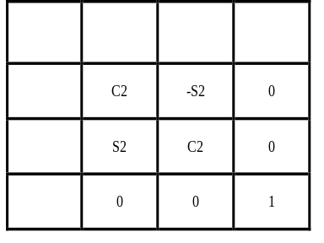
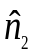
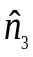

Step 1) Define important points as the center of mass of A and particle P.

Step 2) Select generalized coordinates as shown in the figure and generate velocity and acceleration expressions for the important points.
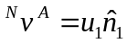 | 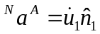
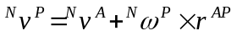
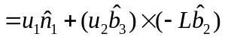
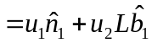 | 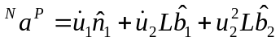
Step 3) Construct a partial velocity table.

 | 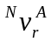 | 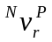
r = 1 | 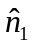
r = 2 | 0 | 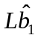
Step 4) 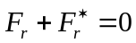

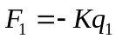
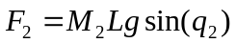 | 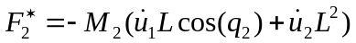

Step 5) Assemble
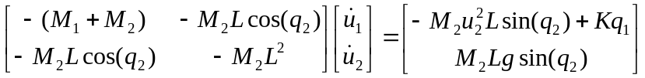

Problem 2
This problem is useful in that it shows how auxiliary generalized speeds can be introduced to bring constraint forces and torques into evidence. In this case we will introduce u₃ to find an expression for T_{c} (constraint torque about 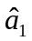). The joints at O and P are revolute. Body A and B are uniform rods with length 4L and 2L respectively. Body A has two times the mass of body B.

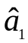
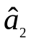
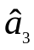
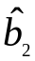
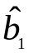
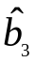
Define the direction cosine matrices:
g
A
B
q₁
q₂
P
O

 |  | 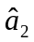 | 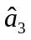
 | C₁ | 0 | S₁
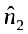 | 0 | 1 | 0
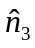 | -S₁ | 0 | C₁

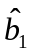 | C₁ | 0 | S₁
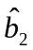 | 0 | 1 | 0
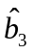 | -S₁ | 0 | C₁

Step 1) Choose important points: Center of Mass of bodies A and B, and point P.

Step 2) Select generalized coordinates as shown in the figure (plus auxiliary generalized coordinate u₃) and generate velocity and acceleration expressions for the important points.

The prime in the equations below indicates that the specified quantities contain the auxiliary generalized coordinate.

Body A
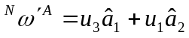
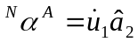
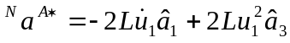

Point P

Body B

Step 3) Construct a partial velocity table.

 | 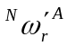 | 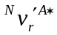 | 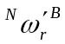 | 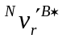
r = 1 |  | 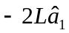 |  | 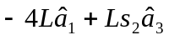
r = 2 | 0 | 0 |  | 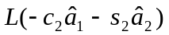
r = 3 |  | 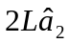 |  | 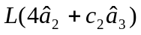

Step 4)

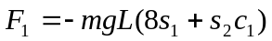
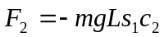
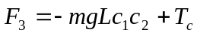

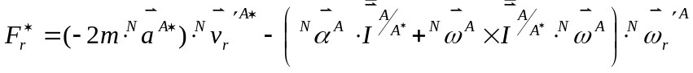
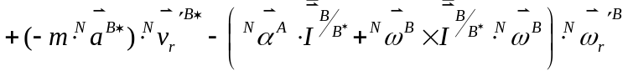

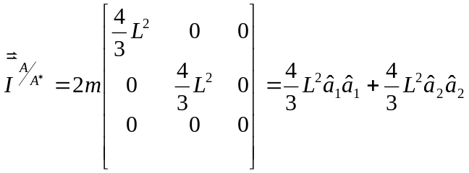
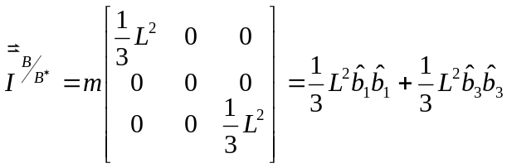
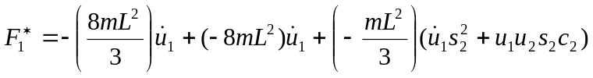

Step 5) Assemble
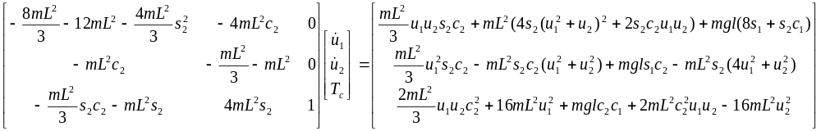
Problem 3
This non-holonomic system demonstrates the usefulness of choosing the generalized speeds to be something other than the first derivative of the generalized coordinates.

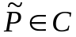
C
q₁
q₂
q₄
q₅
O
Define the direction cosine matrices:
 | C₁ | 0 | S₁
 | 0 | 1 | 0
 | -S₁ | 0 | C₁

 | 0 | 0 | 1
 | S₂ | C₂ | 0
 | -C₁ | S₂ | 0

Step 1) Choose important points: Center of Mass of bodies C, point and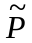(on body C).

Step 2) Select generalized coordinates as shown in the figure and generate velocity and acceleration expressions for the important points.

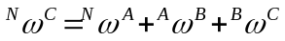
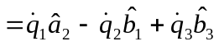

Case A – Choose 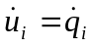 (i = 1,2,…,5)

Imposing the rolling without slip constraint we obtain:
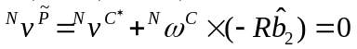

Which gives us constraint relations on 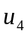and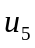
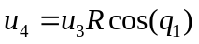
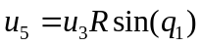
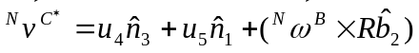
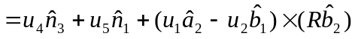

Pluging in the constraint relations allows us to develop the non-holonomic expression for the velocity of the center of mass of body C:
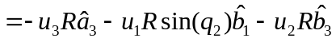
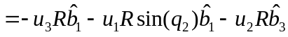

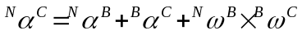

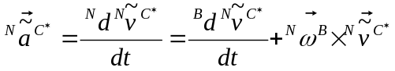

Step 3) Construct a partial velocity table.

 | 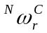 | 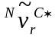
r = 1 | 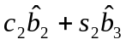 | 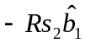
r = 2 | 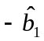 | 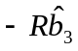
r = 3 |  | 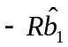

Step 4)

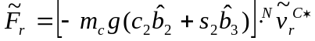
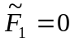
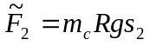
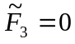

Step 5) Assemble

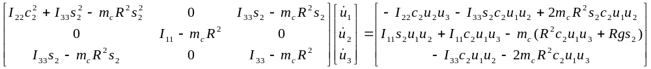
Notice that the inertia matrix, M, is not symmetric. However if the definitions of the generalized speeds are choosen wisely then it is possible to produce a inertia matrix that is symmetric positive definite.

Case B - Choose u₁, u₂, u₃ such that 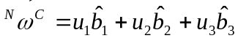

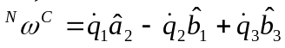

From which we can derive the expressions for u₁, u₂, u₃:
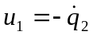
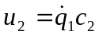
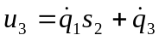

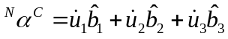

Step 3) Construct a partial velocity table.
r = 1 | 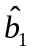 | 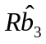
r = 2
r = 3 |  | 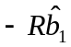
Step 4)

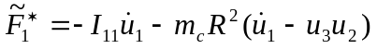
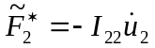
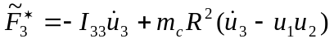
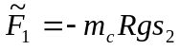
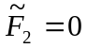

Step 5) Assemble

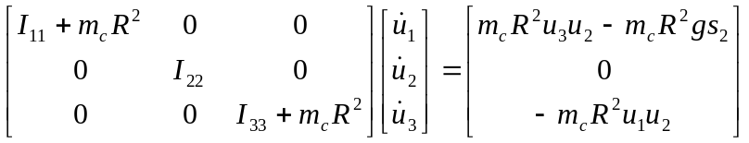

The inertia matrix is now symmetric positive definite.

Conclusions

Although the applications of Kane’s method to multibody systems in this paper has been light, I have shown that is a powerful technique. It offers the advantages of both the Newton-Euler and Lagrange methods in that it can be comprehensive and efficient.
As part of learning Kane’s method I have taught myself how to use Autolev, a dynamics software package that uses Kane’s method to develop equations of motion and perform simulations. In the future I plan on using Autolev to develop equations of motion for a biped. So far I have successfully built simple models of a biped in the frontal plane to compare to published works. The next step is to develop a simple three dimensional model and slowly increase its complexity by adding joints/additional degrees of freedom.
References

Amirouche, Farid M.L. Computational Methods in Multibody Dynamics. New Jersey: Prentice Hall, 1992.

Anderson, Kurt S. Lecture Notes from Applied Multibody Dynamics. Rensselaer Polytechnic Institute 1998.

Critchley, James H. Personal Interviews. February-May 1999.

Critchley, James H. Personal Notes: Kane's Method Application. March 1999.

Huston, Ronald L. Multibody Dynamics. Boston: Butterworth-Heinemann, 1990.

Kane, Thomas R., and David A. Levinson. Dynamics: Theory and Applications. New York: McGraw-Hill, 1985.

