

Personalized Assistant that Learns (PAL)

BAA02-21
U.S. Government Contract Number: N66001-04-D-8014
RADAR Detailed Evaluation Plan
Version 1.11
June 11, 2005

Prepared for the

SPAWAR Systems Center
and
the Defense Advanced Research Projects Agency (DARPA)
By
Information Extraction & Transport, Inc.
Arlington, Virginia
Technical POC  Michael Pool  IET, Inc.  1911 N. Fort Myer Drive, Suite 600  Arlington, Virginia 22209  703-841-3500 voice  703-841-3501 fax  mpool@iet.com email | Administrative POC  Jeffry M. Banes  IET, Inc.  1911 N. Fort Myer Drive, Suite 600  Arlington, Virginia 22209  703-841-3500 voice  703-841-3501 fax  jbanes@iet.com email

Table of Contents

1 Introduction 3
1.1 Evaluation Requirements 3
1.2 DEP Structure 4
1.3 Evaluation Milestones 4
2 Evaluation Hypotheses and Test Conditions – RADAR 6
2.1 Hypothesis 6
2.2 Evaluation Test Conditions 6
3 Evaluation Protocol 9
3.1 Evaluation Schedule 9
3.2 Evaluation Procedures and Mechanisms 9
3.2.1 Recruitment of Test Subjects 12
3.2.2 Test Subjects in Test Conditions 12
3.2.3 RADAR Crisis Scenario 12
3.2.4 Execution of Tests 13
3.2.5 Toolsets and Interactions for Subjects, RADAR, and Test Harness in Each Test Condition 14
3.2.5.1 Control Condition 14
3.2.5.2 EngineeringTestRadar Condition 16
3.2.5.3 LearningTestRADAR Condition 17
3.2.6 Scoreable Outputs and Scoring Rules 19
3.2.7 Scored Data per Test Condition 24
3.3 Evaluation Ground Rules 24
3.3.1 Certification of Interfaces and Training Materials 24
3.3.2 Automated and Semi-Automated Training 24
3.3.2.1 Wargaming 25
3.3.3 RADAR Networking 25
3.3.4 System Repairs 26
3.3.5 Supplemental Data 26
4 Evaluation Materials Generation 26
4.1 Materials Generation Overview 26
4.2 Evaluation Scenarios 29
4.2.1 Background Knowledge 30
4.3 Evaluation Ontology 30
4.4 Crisis Parameterization 31
4.4.1 Sample of Element Types and Properties 31
4.5 Test Generation Process – Coverage and Consistency Analysis 33
5 Results Analysis 34
5.1 Analysis Overview 34
5.1.1 Measures of Performance 35
5.1.1.1 Intra-System Yearly Comparison 35
5.1.1.2 Learning measurements 36
5.1.2 Post-test Analysis of Evidence 37
5.1.3 Data Analysis Concerns 37
5.1.4 Data Analysis Recommendations 38

Introduction
This document presents the Year 2 Detailed Evaluation Plan (DEP) for Carnegie Mellon University’s (CMU’s) Reflective Agent with Distributed Adaptive Reasoning (RADAR) system. This work is done for the Personalized Assistant that Learns (PAL) program of the Defense Advanced Research Projects Administration (DARPA).
PAL is a five-year program to develop integrated cognitive systems and make major advances in each of the following technology focus areas:
- Learning;
- Representation and Reasoning;
- Communications and Interaction;
- Computational Perception.
IET's role in the PAL program is that of independent evaluator. In this capacity, IET has the following responsibilities:
- Providing an evaluation framework for the PAL evaluations;
- Supporting population of that framework for each of the PAL contractors;
- Codifying and validating each contractor's evaluation plan;
- Providing oversight of PAL evaluations for each contractor;
- Scoring evaluations;
- Analyzing evaluation results;
- Developing scientifically sound methods to evaluate advanced cognitive computational capabilities.
A full discussion of the above, as presented in the RADAR Broad Evaluation Plan (BEP) released in July 2004, is available in Appendix A.
Version 1.01 updates the April 15 Version 1.0 with some changes to the scoring procedure, Section Section 3.2.6.

Evaluation Requirements
The RADAR evaluations have the following Government-provided requirements:
- The evaluation domain is event replanning;
- The protocol and domain will be kept fixed throughout the life of the program;
- The evaluation design must avoid any ceiling effects in Year 5 of the program, requiring an evaluation which is sufficiently challenging to motivate breakthroughs in automated cognition and learning throughout the life of the program;
- The evaluation design must be consistent with motivating developers to create reusable, appropriately generalized technology;
- There must be a clear demonstration of progress across comparable evaluations for each program year;
- Progress must be shown in RADAR’s ability to learn, both through training and by “learning in the wild” (LITW), enabling performance improvements in each program year;
- Progress must be shown in RADAR’s ability to act as a cognitive agent, enabling performance improvements in each program year.
These requirements inform the design of the evaluation model specified here.

DEP Structure
The structure of the DEP is as follows:
- Introduction (Section 1);
- Evaluation Hypotheses and Test Conditions (Section 2)
- Test Protocol (Section 3);
- Evaluation Materials Generation (Section 4);
- Results Analysis (Section 5).
The following background and detailed material appear in the appendices:
- Cognitive Systems Evaluation Overview (Appendix A);
- The RADAR Crisis Parameterization (Appendix B);
- The RADAR Evaluation Ontology, version 1.0 (Appendix C);
  - Crisis parameters are formally represented
- Scoring Plan, version 1.0 (Appendix D);
- Sample evaluation scenarios (Appendix E).

Evaluation Milestones
The Year 2 (Y2) End-to-End RADAR system evaluation is scheduled to begin in summer, 2005. For Y3-Y5, RADAR Evaluations will be conducted each summer and may also include evaluation cycles each program year to further aid development and testing. In Figure 3 we show a series of three evaluations run one after the other. Currently, CMU is not required to conduct evaluations more than once a year. There is interest at CMU in doing continuous
development and evaluation cycles, motivated by the fact that this is a first-of-its-kind
system and further research is going to be best identified through running and testing the system. Below, IET charts the path between now and the production of the next year’s BEP.

Year 2 Task / Documents | Produced by | Due Date
Pilot Cycle
Year 2 Detailed Evaluation Plan (DEP) | IET | March 15, 2005
RADAR Pilot Evaluation | CMU & IET | Jan - April, 2005
Plan update
Updated Y2 DEP (Based on pilot results) | IET | April 15, 2005
Revisions to Test Backstory Materials, if any | CMU & IET | April 20
Development & Testing Cycle 1.0
Y2 RADAR 1.0 Released, installed on user desktops | CMU | May 2 2005
Y2 EngineeringTestSnapshot created, delivered to IET | CMU | May 6 2005
Y2 Training Sessions, a.k.a. “wargaming” Period | CMU | May 2005
Y2 Testing performed (as per Section 2.2) | CMU | June 2005
Y2 Final snapshot data extracted delivered to IET | CMU | July 1, 2005
Y2, Test results scored | IET | July 5-13, 2005
Analysis
Y2 “Quick Look” Evaluation Results delivered | IET | July 15, 2005
Y2 Evaluation Report with Full Results Analysis delivered | IET | July 29, 2005
Development & Testing Cycle 1.1 (Compressed)
Y2v1.1 RADAR Released, installed on user desktops | CMU | July 15 2005
Y2v1.1 EngineeringTestSnapshot created, delivered | CMU | July 20 2005
Y2v1.1 Training Sessions, a.k.a. “wargaming” Period | CMU | July 18–Aug 12 2005
Y2v1.1 Testing performed (EngineeringTestSnapshot testing overlaps with LearningTestSnapshot training) | CMU | August 8 – Sept 2, 2005
Y2v1.1 Final snapshot data extracted, delivered to IET | CMU | Sept 7, 2005
Y2v1.1 Test results scored | IET | Sept 14, 2005
Analysis of v1.1 results
Y2v1.1 “Quick Look” Evaluation Results delivered | IET | Sept 16, 2005
Y2v1.1 Evaluation Report with Full Results Analysis delivered | IET | Sept 30, 2005
Preparation for Year 3
Year 3 Broad Evaluation Plan (BEP) Update delivered | IET | Aug 19, 2005

Table 1: Year Two Evaluation Milestones

Evaluation Hypotheses and Test Conditions – RADAR

Hypothesis
The RADAR system is designed as a tool with learning capabilities that will allow success in replanning tasks under conditions that would overwhelm a human not assisted by RADAR. More precisely, the evaluation hypotheses are as follows:
- Hypothesis 1: A human assisted by RADAR with prior learning will outperform a human assisted by RADAR without prior learning on crisis replanning tasks.
  - This hypothesis will be demonstrated in Years 2 through 5 of the PAL program.
- Hypothesis 2: A human assisted by RADAR with prior learning will outperform a human using conventional office tools on crisis replanning tasks.
  - This hypothesis will be demonstrated in Years 2 through 5 of the PAL program.
- Hypothesis 3: A human assisted by RADAR with prior learning will outperform a human with a human assistant on crisis replanning tasks
  - This hypothesis will first be tested in Year 3 but is not expected to be demonstrated until Year 4 of the PAL program.
These hypotheses are verified by comparing the performance across four test conditions described in Section 2.2.

Evaluation Test Conditions
The evaluation of RADAR evaluation hypotheses relies upon a comparison of performance on an event replanning task under four test conditions:
- Test Condition 1 (TC1): Condition 1 involves testing humans assisted by RADAR systems that contain no learned knowledge. RADARs that do not have prior learning will be referred to as EngineeringTestRADARs.
- Test Condition 2 (TC2): Condition 2 tests the performance of subjects who are using RADAR systems that have been subjected to a learning period. These RADARs, known as LearningTestRADARs, will be provided to the evaluation subjects having learned through training scripts and interaction with other human subjects.
- Test Condition 3 (TC3): Condition 3 tests subjects using conventional office tools for the event replanning task. Conventional office tools include word processors, spreadsheet packages, personal scheduling tools (such as Outlook), email programs, instant messengers, web meeting programs, and applications such as the calculator found on most desktops. We will refer to such systems as ConventionalToolsTestSystems.
- Test Condition 4 (TC4): Condition 4 tests subjects assisted by human assistants. A human assistant will be provided to each test subject, as well as conventional office tools. The assistant will be familiar with the evaluation scenario but will not have prior experience with crisis replanning tasks. The systems used in Test Condition 4 are the same as those used for Test Condition 3, and will also be called ConventionalToolsTestSystems.
  - In order to make a comparison between the performance of subjects in Condition 4 and Condition 2, the human assistant will be given additional training on useful tools for event planning and on event planning scenarios, in much the same way as the RADAR with learning (LearningTestRADAR) will have been exposed to several replanning scenarios prior to the evaluation.
  - There is some concern that the trained human assistant could take over the replanning tasks, in the same that a new executive may defer to a trained assistant. This will be investigated during pilot studies.
Figure 1 shows the initial conditions at the start of the Year 2 RADAR evaluations. Test subjects will perform the evaluation tasks while using a workstation in one of the four test conditions. Engineering development of the RADAR system will be on-going but for a single evaluation, RADAR systems will not undergo any additional engineering improvements. Office tools provided to test subjects in Conditions 3 and 4 remain unchanged throughout a single evaluation. These tools will also utilize RADAR GUIs (e.g.; the Space Time Planner) and RADAR as a data collection device running in the background.
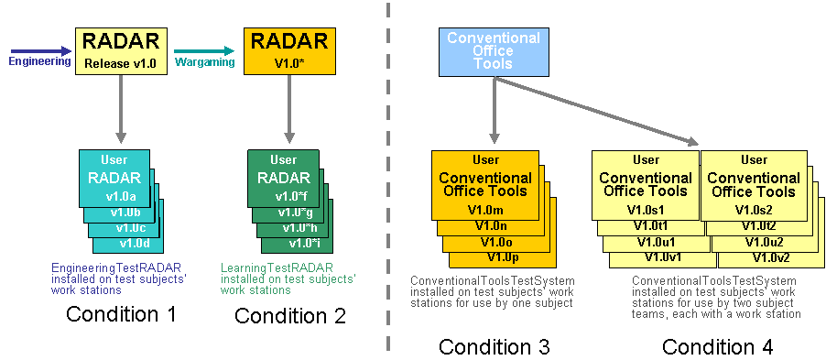
Figure 1 Initial Evaluation Conditions
A Test Harness (TH) will work with the evaluation test systems to monitor the subjects and configure the test. At the start of each test the TH will tell RADAR which, if any, specialists to utilize (given the test condition) and will utilize RADAR monitoring capabilities to record subject actions through a Specialist Logging module. This module will be responsible for routing all data collected into the subject’s database. CMU will output evaluation data in an IET-specified scoreable format. Evaluation data includes:
- The event schedule, including rooms, equipment, speakers, times, vendors, and other schedule components.
- Performance data on tasks including:
  - Message recipients
  - Time of response
  - Content (emails, briefing).
- More?

Over the course of an evaluation period, several snapshots will need to be taken. These snapshots will be used to maintain workstations used by test subjects across multiple evaluation sessions. Beyond that, the snapshots are for archival purposes only and will not be directly scored.
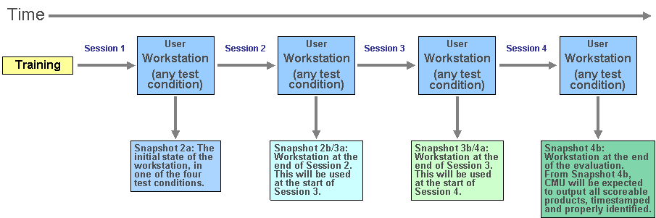
Figure 2 Evaluation Snapshots
Figure 2 indicates system snapshots taken at different points in time. Snapshot 4b system will be the source of all scored products – briefings, website updates, and the event schedule – with the required time stamping (needed to score the timeliness of response) and additional metadata.
We adopt the following protocol for the handling of snapshot 4b:
- Data for IET scoring will be extracted from subject’s database and sent to IET.
- Entire subject directory (database, IMAP folders, conference website, etc) will be archived to 2 locations (archive and analysis). These will be on different machines and preferably in different buildings. Ideally, these will also be machines on regular SCS Facilities back-up schedules.
- The archive copy will have limited access and will not be utilized except for cases of emergency.
- The analysis copy will have the subject’s data in a read-only directory under the control of the Test group. There will be scratch space for active analysis and collation by interested parties. These individuals must complete IRB training and provide such documentation to the CMU Test group and CMU IRB.
- When key master data documents are constructed (i.e., data files for test-wide analysis) they will be placed at both locations and stored in read-only directories.
- We are assuming that some data may have accidental documentation of subject identity (e.g., email signatures, etc). As time permits and as a byproduct of certain analyses, “clean” anonymous master documents may be generated for wider dissemination to teammates who have not completed IRB training.

Evaluation Protocol
The evaluation of the RADAR system is always done in the context of systems assisting humans, as opposed to the CALO evaluations where the system alone is evaluated. In the protocol, we provide the following information:
- Evaluation schedule (Section 3.1);
- Evaluation procedure and mechanisms (Section 3.2);
- Evaluation ground rules (Section 3.3).

Evaluation Schedule
Given the abbreviated development period in Year 2, the learning period will be shorter for Year 2 evaluations than in the outlying years. Figure 3 shows the evaluation schedule for Year 2, permitting CMU to fit two rounds of tests into the Year 2 cycle. In May, RADAR 1.0 will undergo a one month learning period (“L”), followed by a one month testing period (“T”), and concluding with a one month assessment period (“A”) in June. The second cycle will overlap the first, beginning in mid-June and following the same sequence but with slightly more abbreviated time periods for each evaluation component.
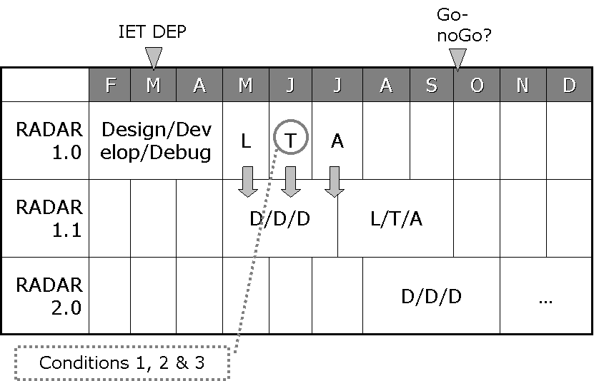
Figure 3 Year 2 Evaluation Schedule
At a minimum, full evaluations, using as many as thirty subjects in each test condition, will be run annually each summer. Upon completion of pilot studies and the Year 2 test, IET will confer with CMU and the Government to decide if mid-year or quarterly evaluations are needed in order to properly characterize RADAR’s performance. CMU supports the idea of quarterly evaluations.

Evaluation Procedures and Mechanisms
As CMU is running the evaluations, it is the University’s responsibility to administer all matters related to the use of human subjects, where this includes the proper handling of subjects’ identifications and actions during the evaluations as well as the data generated during each evaluation.
The sequence of events for each evaluation is as follows:
Preconditions:
- CMU has received approval by their internal IRB to conduct human subjects testing.
- The RADAR interfaces and general office tools have been certified by IET.
- The training materials have been certified by IET.
- An evaluation lab has been set up.
For each evaluation:
- CMU recruits test subjects.
- Evaluation session 1: CMU trains test subjects, introducing the tools to be used as well as the general scenario of event replanning to be used throughout the evaluation.
- Evaluation session 2: Evaluation subjects begin to work at workstations in groups of ten, all in the same test condition.
  - This will involve learning of the major crisis, beginning to replan the event while receiving perturbations, background tasks, and “noise” events.
  - The subject will be creating email queries, response, briefings, vendor requests, vendor agreements, and conference plans using web-based interfaces, email and test condition appropriate RADAR interfaces.
  - At the end of the session, a snap shot of each system will be taken for use at the next session.
- Evaluation session 3: A continuation of session 2, with the subject continuing to replan the event while continuing to receive perturbations, background tasks, and “noise” events.
  - The subject will be creating email queries, response, briefings, vendor requests, vendor agreements, and conference plans.
  - At the end of the session, a snap shot of each system will be taken for use at the next session.
- Evaluation session 4: The final session will see the test subject concluding the replanning of the event, creating an event schedule (or conference plan) with goods and services agreements with vendors. The rate of perturbations, background tasks, and “noise” events will decrease to allow the subject to complete the schedule.
  - The subject will be creating email queries, response, briefings, vendor requests, vendor agreements, and conference plans.
  - At the end of the session, a snap shot of each system will be taken for evaluation purposes.
- Performance data scored according to stated criteria. (Section 3.2.6)
  - IET provides unanalyzed scored performance data, followed by lightly-analyzed “Quick Look” data, to CMU and DARPA.
Data, Document, or Process | Description | References
Recruitment of Test Subjects | CMU will recruit students from the local universities | Section 3.2.1
Test Subjects in Test Conditions | Overview of training, both on event planning and on the particular work stations, that subjects’ will receive | Section 3.2.2
Crisis Scenario | Description of the scenarios that will be used for each year’s evaluation | Section 3.2.3
Execution of Tests | High-level description of RADAR evaluations, and inputs and outputs between subjects and test harness | Section 3.2.4
Scoreable Outputs | Identification of evaluation subjects’ products to be scored | Section 3.2.6
Scoring Rules | Scoring rules for each scored product | Section 3.2.6
Scored RADAR Performance Data | Pre-analysis scores for each Test system. | Section 3.2.7
Table 2 Evaluation Protocol definitions

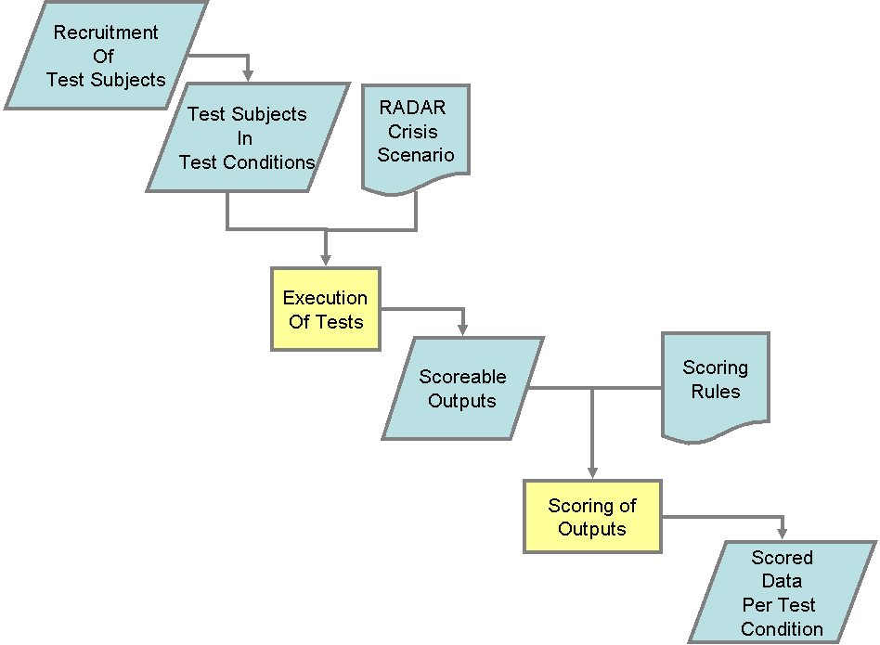
Figure 4 Evaluation Protocol Overview
The Evaluation Protocol Overview diagram in Figure 4 depicts the major data, documents, and processes comprising the RADAR evaluation process. Each element of this protocol is discussed in detail below. Table 2 provides a brief description of each element, along with a reference to more detailed discussion.

Recruitment of Test Subjects
CMU will be responsible for recruiting test subjects out of the local student body population. It is expected that test subjects will be undergraduates with no experience in event planning or replanning. In order to maintain subjects in the test subject pool, a series of incentive payments will be made based on performance during the three evaluation periods. CMU has presented and gained approval for their evaluation plan by CMU’s internal IRB.

Test Subjects in Test Conditions
Test subjects will be asked whether or not they have any previous experience related to conference planning. CMU will attempt to slot people with relevant experience to achieve a balance across the test conditions. Beyond such considerations, subjects will be randomly assigned to one of the four test conditions (or three test conditions in Year 2). During training, all subjects will be given the same overview of event planning and the expectations in place during the evaluations. Once assigned to a test condition, each subject will be given any condition-specific training that is required, including training on software tools. At this point, subjects will be given a basic skills test to ensure that they can appropriately use the available software tools. Subjects failing this test will not be used during evaluations.
IET will review the training materials to make sure that there is no unintentional advantage given to subjects in one condition versus another. If there are any issues with the training materials, a report detailing the concern will be provided to CMU, as well as suggested changes to be made. In order to ensure sufficient time for review and edits, training materials should be provided to IET as soon as possible but no later than one month prior to the Year 2 evaluation.
A test subject will be considered to be in a test condition after receiving general training on event planning, specific training related to the tools to be used in the test condition, and being assigned to a work station with the appropriate test materials loaded and ready for use.

RADAR Crisis Scenario
A crisis scenario is composed of:
- A backstory including the entire history of the event plans up to the start of the evaluation period. The backstory will include:
  - The predecessor’s conference plan and stored e-mail, including noise messages and any messages needed to complete background tasks (if any).
  - Web-based vendor database and order forms.
  - The schedules of those who will be at meetings.
  - Pop-up e-mail, including noise and background task stimuli.
  - Logic fed e-mail – e.g., vendor and resource request emails.
  - Web-based description of resource existence and availability.

The backstory corpus will be a constructed corpus but may utilize anonymized real corpus parts where appropriate (e.g., noise messages, room details). All requests for structured actions/information will be via web forms (e.g., caterer shifts, room requests) since automatic or Wizard of Oz handling of subject e-mails should be at a minimum.
- A major crisis that requires the original event, as detailed in the backstory, be replanned. This major crisis will be revealed to test subjects through incoming emails. The dimensions of a major crisis are described in Section 4.4 where we discuss crisis parameterization.
- Minor perturbations that have an impact on the replanning task. Perturbations will be sent to the evaluation subjects as a way to ensure that the replanning task remains overwhelming as well as ensuring a degree of realism to the overall evaluation model. Perturbations are discussed in Section 4.4 where we discuss crisis parameterization.
- Background tasks that are not related to the event replanning tasks but do require some response from the test subject. These tasks will be simple and easy to accomplish, requiring the subject to do such tasks as going to a website and answering a straight forward question.
- “Noise” data not related to any task requiring a response on the part of the subject. An example of noise data would be spam email in the subject’s email inbox – the subject must (with or without the help of RADAR) screen out such data in order to stay focused on the required tasks.
The backstory and supporting materials (such as possible room layouts, room sizes, required email format) are available from CMU.

Execution of Tests
CMU will be setting up a computer lab in order to run RADAR evaluations. The lab will contain workstations for test subjects, and additional instrumentation as possible/feasible. CMU personnel will be present during each test and IET will be allowed to observe in compliance with human subjects testing requirements.
Tests will begin after subjects have received training and been assigned to a work station. Subjects will be run idependently in cohorts of ten, each in the same test condition. There will be four sessions, each one and a half hours long, with the first session focused solely on training. In each test session, CMU will control the information given to test subjects and will make sure that all materials are collected at the end of each session. To maintain consistency, the period between test sessions will be kept constant across all test conditions.
CMU will be collecting data from the subjects’ workstations continuously during each session. Performance during each session will be used to calculate milestone payments for subjects based on progress made. Milestone payments will be used to motivate students to perform well and to remain in the evaluation
During the second test session, subjects will receive information regarding the minor crisis. They will also need to deal with minor perturbations, background tasks, and “noise” events. Subsequent sessions will build on the achievements of the previous session, with the subject told that an event schedule will be expected at the end of the fourth session.
Throughout each test session, CMU personnel will be on hand. If test subjects have any questions, they will be referred to the provided materials. This will be done in order to avoid interaction effects between the CMU personnel and test subjects.

Toolsets and Interactions for Subjects, RADAR, and Test Harness in Each Test Condition

Control Condition

Toolset

Current plan
Outlook IMAP
- Free form briefing construction.
Web browser
- Vendor forms, conference website, hotel website, CMU UC and Stever websites.
- Web form for viewing room availability and requesting bumps.
- Manuals or training materials available to the subjects in real time.
- Web updates to conference website.
STP GUI
- Freestanding from web browser and Outlook
Outlook To Do
Posted schedule on the conference website
- Website-based schedule and update forms

Variations, if logistically possible
This list routes more of the Control interaction into the Radar UIs. This makes it easier to collect data and keep the UI features that do not reflect learning constant across the conditions. However, there are significant logistical barriers to implementation, namely time, which may prevent these from being used. As in the current plan, all Radar UIs would be “dumb” and lack optimization and learning.

STP GUI
- Including room availability viewing and bump requests
Radar To Do/Done panes of Console
- No intelligence, just a list.
- Right click in email to create a new To Do item (like Radar, but one choice).
- Can migrate items from To Do to Done.
Radar Briefing Maker UI
- One window that only shows fields to fill in bullet points and some widget to route it to email. This would keep briefings during Control in the same format as in Radar, thus making analysis easier.

Input from subject to Test Harness
Name | Type | Content | Notes
Sent e-mail | Freeform e-mail | Progress reports; Pointers and information in response to queries | Briefings may be composed with the help of Radar components (see below)
Web forms | Structured field entries | Requests and queries for vendor quotes, web changes, schedule changes, room requests, etc

Output from Test Harness to subject
Name | Type | Content | Notes
Base e-mail | Static e-mail | All messages collected by original conference planner, including noise and background task stimuli (if any) | Present in IMAP collection  The subject may never read some of this material
Timed  e-mail | Injected static e-mail | Incoming requests, queries, noise, and background stimuli | Response times and arrival of uninitiated incoming messages will be pre-set
Scripted  e-mail | Dynamic  e-mail | Responses as a result of subject actions | Mostly from web forms
Base web | Static web | Vendor lists, initial website, etc
Timed web | Injected web | Changes in vendor lists, room availability, etc

Input from subject to Radar
Name | Type | Content | Notes
Radar UI | Radar input | STP GUI manipulation; Possibly Briefing Maker UI, Console To Do/Done lists, and issuing room request | Standardizing non-learning UIs

Output from Radar to subject
Name | Type | Content | Notes
Radar UI | Radar output | STP GUI viewing; Possibly simple transport of Briefing Maker UI content to email message and room availability information | Standardizing non-learning UIs

Output from Radar to Test Harness
Name | Type | Content | Notes
Radar Acquired Data | Logging | Instrumented legacy applications (e.g., Outlook); Activity data; Interactions with UIs | Standardizing data collection and leveraging instrumentation

EngineeringTestRadar Condition

Toolset

Current plan
Outlook IMAP
- Manual task classification.
Web browser
- Vendor forms, conference website, hotel website, CMU UC and Stever websites.
- Manuals or training materials available to the subjects in real time.
Radar Console
- GUI for Summary, To Do, Done, etc
- Manual task classification.
- Activation of CMRadar queries.
- Manual input of STP constraint and room availability modifications.
- Manual VIO form filling.
STP
- Freestanding GUI and optimizer only.
CMRadar
- Simple search, no learning.
- Form based.
Briefing Maker
- Freestanding GUI
- No learning, just random sort.
Posted schedule to the conference website
- Manually driven VIO forms in Radar Console or website-based update forms.

Variations, if logistically possible
STP GUI
- Including room availability viewing and bump requests.

Still Undetermined
Briefing Maker
- Auto-population from Radar Console To Do and Done lists?

Input from subject to Test Harness
Name | Type | Content | Notes
Sent e-mail | Freeform e-mail | Progress reports; Pointers and information in response to queries | Briefings will be composed with the help of Radar components
Web forms | Structured field entries | Requests and queries for vendor quotes, etc

Output from Test Harness to subject (same as Control, excepting Timed Radar)
Name | Type | Content | Notes
Base e-mail | Static e-mail | All messages collected by original conference planner, including noise and background task stimuli (if any) | Present in IMAP collection  The subject may never read some of this material
Timed  e-mail | Injected static e-mail | Incoming requests, queries, noise, and background stimuli | Response times and arrival of uninitiated incoming messages will be pre-set
Scripted  e-mail | Dynamic  e-mail | Responses as a result of subject actions | Mostly from web forms but may result from specialist actions (e.g., room requests)
Base web | Static web | Vendor lists, initial website, etc
Timed web | Injected web | Changes in vendor lists, room availability, etc
Timed Radar | Injected Radar | Possibly room availability | Timing and changes would be identical to Control case

Input from subject to Radar
Name | Type | Content | Notes
Radar UI | Radar input | Console Summary and To Do/Done lists; Task classification forms; STP GUI; Briefing Maker UI; Room request and web update forms | A function of the Radar release components and UI

Output from Radar to subject
Name | Type | Content | Notes
Radar UI | Radar output | Console; STP GUI; Briefing Maker UI; Room search results | A function of the Radar release components and UI

Output from Radar to Test Harness
Name | Type | Content | Notes
Radar Acquired Data | Logging | Instrumented legacy applications (e.g., Outlook); Activity data; Interactions with UIs; Radar specific actions | Standardizing data collection and leveraging instrumentation

LearningTestRADAR Condition

Toolset

Current plan
Outlook IMAP
- Semi-automatic task classification.
Web browser
- Vendor forms, conference website, hotel website, CMU UC and Stever websites.
- Manuals or training materials available to the subjects in real time.
- WBE activation and interaction.
Radar Console
- GUI for Summary, To Do, Done, etc.
- Semi-automatic task classification.
- Activation of CMRadar queries.
- Semi-automatic input of STP constraint and room availability modifications.
- Semi-automatic VIO form filling.
- WBE activation.
STP
- Freestanding GUI, optimizer, and learning.
- Elicitation of information (via Radar Console).
CMRadar
- Search with learning.
- Form based
Briefing Maker
- Freestanding GUI and learning.
Posted schedule to the conference website
- Semi-autonomous VIO forms in Radar Console
- WBE
- If the subject feels the urge to do it manually, website-based update forms

Variations, if logistically possible
STP GUI
- Including room availability viewing and bump requests.

Still Undetermined
Briefing Maker
- Auto-population from Radar Console To Do and Done lists?

Input from subject to Test Harness
Name | Type | Content | Notes
Sent e-mail | Freeform e-mail | Progress reports; Pointers and information in response to queries | Briefings will be composed with the help of Radar components
Web forms | Structured field entries | Requests and queries for vendor quotes, etc

Output from Test Harness to subject (same as Radar-L)
Name | Type | Content | Notes
Base e-mail | Static e-mail | All messages collected by original conference planner, including noise and background task stimuli (if any) | Present in IMAP collection  The subject may never read some of this material
Timed  e-mail | Injected static e-mail | Incoming requests, queries, noise, and background stimuli | Response times and arrival of uninitiated incoming messages will be pre-set
Scripted  e-mail | Dynamic  e-mail | Responses as a result of subject actions | Mostly from web forms but may result from specialist actions (e.g., room requests)
Base web | Static web | Vendor lists, initial website, etc
Timed web | Injected web | Changes in vendor lists, room availability, etc
Timed Radar | Injected Radar | Possibly room availability | Timing and changes would be identical to Control case

Input from subject to Radar
Name | Type | Content | Notes
Radar UI | Radar input | Console Summary and To Do/Done lists; Task classification forms; STP GUI; Briefing Maker UI; Room request and web update forms | A function of the Radar release components and UI

Output from Radar to subject
Name | Type | Content | Notes
Radar UI | Radar output | Console; Semi-automatic form filling; STP GUI and elicitations; Briefing Maker UI with intelligent sort; VIO and WBE feedback; Room search results and feedback | A function of the Radar release components and UI

Output from Radar to Test Harness
Name | Type | Content | Notes
Radar Acquired Data | Logging | Instrumented legacy applications (e.g., Outlook); Activity data; Interactions with UIs; Radar specific actions | Standardizing data collection and leveraging instrumentation

Scoreable Outputs and Scoring Rules
Scoreable outputs of a RADAR evaluation session will include a conference schedule, updates to internal and external websites and briefings. Schedule information that is to be scored by IET must be specified in terms of the IET RADAR evaluation ontology. Any schedule component scores that are generated by the RADAR test harness also require some audit method, i.e., some way to access the information used in generating the score and clear instructions for accessing that information.
Subject performance on a series of background tasks will also be assessed. Subject performance on a series of background tasks will also be assessed, scoreable output of these tasks will be in the form of email messages in a specific XML format,
Implementing the methodology of multi-attribute utility theory (technology) and Analytic Hierarchy Process, the output features relevant to generating a useful schedule and notification outputs have been decomposed in a hierarchical fashion. Each relevant performance feature has been decomposed into subcomponents until the structure decomposes into features for which it is possible to state a relatively direct scoring method. The result is a hierarchical taxonomic structure from the most general root node, OverallScore (Figure 5) or ScheduleQuality (Figure 6-Error: Reference source not found), through component nodes down to leaf nodes. Each node in the resulting structures, other than the root node, is assigned a weight relative to the other nodes in the same level in the hierarchy. The weight of a node is indicative of that node’s relative importance in terms of its contribution to the quality of its parent node. For any given node, the weights of its children must sum to 1. Given a scoreable object and calculated score (between 0 and 1) for each leaf node for that output, the value of any other node, i, in the tree can be calculated as follows:
Score_{i} = $\sum_{j=1}^{n}{({\text{weight}}_{\text{i,j}})}({\text{score}}_{\text{i,j}})$
Here ‘weight_{i,j}’ denotes the weight of the j^{th} child of node i (assuming some arbitrary linear ordering of the children) and ‘score_{i,j}’ denotes the score for that and n is the number of children of node i.
Two trees are being implemented in calculating the score. One of the trees, see Figure 6-Error: Reference source not found, is for calculating schedule quality and the other, see Figure 5, is for calculating the overall score in an evaluation task. The schedule quality is, of course, an input into the overall score.
The following scoring procedures being implemented:
- Briefings will presumably require human scoring. Requisite website updates will be flagged as part of the evaluation crisis definition as will the time that the information becomes available. Briefing scoring will consider whether briefings match a preset prioritized list.
- Website updates scoring will consider whether changes to the schedule have been regularly submitted to the website. Updates to contact information and other information update requests will be checked for each session. Updates to the schedule will be checked at the end of the third session.
- Schedule Quality: The constraints, preferences and requirements associated with each evaluation crisis and associated perturbations will be represented formally using the Radar Evaluation Ontology. For each leaf node in the schedule quality tree, Appendix D discusses a scoring procedure so that the query or algorithm for calculating it is sufficiently clear, given the formalization of the schedule and constraints and preferences in terms of the RADAR evaluation ontology. The implementation of the space-time planner is likely the most efficient way to calculate scores for many of the leaf nodes in the ScheduleQuality tree. This scoring process must be auditable. Where it is not possible to use the space-time planner to calculate scores, it will be necessary that the relevant components of the schedule and backstory (including constraints and preferences that predate the evaluation crisis and parameter and left unchanged by it) be output by the system specified in terms of the RADAR Evaluation ontology. Settling how much of the scoring can be completed by the space-time planner is an important near term requirement, as this impacts the development of code for scoring other factors. Some prioritization of the scoring factors should be done so that we can drop less relevant factors if this will ease the creation of the scoring code.
- Scoring the background tasks requires a mechanism that records if and when responses associated with the background task have been made, whether the response given was correct.
  - Given that background tasks will arrive in email, scoring may also be devised to take into account how long it takes for the subject to open an email with a background task in it, and then how long it takes the subject to actually got to the website for the background task.
In addition to the specifications given in the detailed breakdown of the scoring procedure, some of the features represented in a node will face hard constraints that are prerequisites to obtaining any score at all. For example, to obtain any score on a keynote session, one cannot have booked a speaker during a time at which s/he will not be present and/or booked a speaker to be participating in parallel events.
The diagrams below offer a high level overview of the hierarchical decomposition in the form of graph diagrams with some of the most important weights listed. A more detailed breakdown of the scoring formulas and the anticipated process for calculating values for the leaf nodes is given in Appendix D. Note that Error: Reference source not found decomposes one of the leaf nodes, ‘DayNSessionQuality’, of Figure 6, while Error: Reference source not found decomposes one of the leaf nodes, ‘IndividualSessionN’, of Error: Reference source not found.

.10
.6
.3
.5
.5
Figure 5 Scoring Tree for Overall Score
Figure 5 depicts the high level factors that are considered in generating a score for the outputs of a RADAR session.
The schedule is weighted at .6 and the quality of communication work performed by the user is weighted at .3. These weights are based on considerations about the kinds of things that would be required as outputs in a real crisis scenario, i.e., performance on this component of the task directly reflects success in central tasks in crisis replanning. Background tasks are weighted at .10 so that RADAR performance score also reflects RADAR’s utility in freeing up time for users to carry on with regular tasks in the face of unexpected work. The value for ‘ScheduleScore’ is calculated as follows:
ScheduleScore = $\text{max}(0\text{,max}(1,(\text{ScheduleQuality}−((1−(\frac{1}{\sqrt[n]{\frac{\text{DollarCost}}{\text{DollarBudget}}}}))+(1−(\frac{1}{\sqrt[m]{\frac{\text{RequestCost}}{\text{RequestBudget}}}}))))))$

See Appendix D for more discussion.
Schedule quality is decreased by a cost factor that decreasess quality scores to the extent that they have overrun monetary budgets or their “budget” for room requests. This formula allows for an adequate penalization of schedules where implementation would incur large cost overruns but it also has the effect of otherwise minimizing the extent to which cost is a central focus in generating a schedule, i.e., small underruns or overruns have minimal effect on the scores.
Figure 6 is a diagram indicating the factors relevant to assessing Schedule Quality. The Session quality score reflects the quality of the event’s technical sessions. The score for special event quality is based on the quality of the less technical but highly attended events that occur during the event. The score for overall conference quality reflects the quality of administrative and background support for the conference when those factors have not been otherwise already factored in.
.6
.25
.15
Figure 6: ScheduleQuality (See other figures for expansion of 'DayNSessionQuality')

As indicated in Figure 6, Session quality is now calculated by factoring in the quality of the technical sessions, the poster demo sessions, the workshop sessions and the plenary sessions rather than by calculating a distinct quality score for each day. Consideration of meals and breaks is now considered in “OverallConferenceQuality” and a number of factors deemed to be irrelevant were removed from consideration. This included things like distance between buildings and rooms, parking and accommodations..

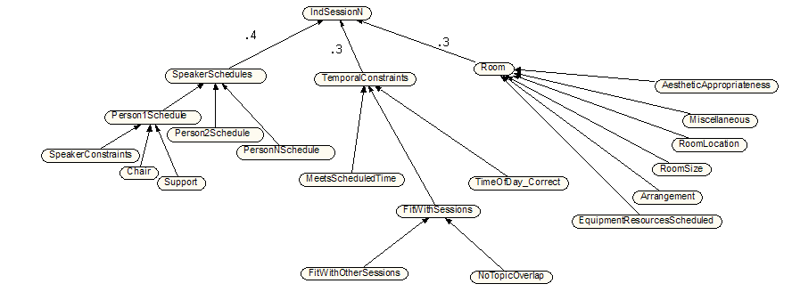
Figure 7: Score for an Individual Session

Error: Reference source not found indicates the scoring factors for an individual session. An individual session is scored on the basis of whether it meets the constraints on the events, on the time of the speakers, room constraints and preferences and whether appropriate services have been scheduled. Unlike the previous scoring plan, a distinction is made between session types, e.g., workshop vs. tutorial vs. plenary vs. panel session, in this scoring model.

Scored Data per Test Condition
The scoring process described above results in a score for the performance of the subject in a test condition. Scored performance data is unanalyzed, containing simply the computed score per subject in test condition. To produce “Quick Look” reports, IET will perform basic analysis such as average and mean results within sets of data, as well as comparison between such sets. At the end of each testing round, scored performance data will be made available by IET, to CMU and to DARPA. “Quick Look” reports will follow shortly thereafter.

Evaluation Ground Rules
Inevitably, issues will develop throughout the year. As necessary, IET will prepare a brief report on an evaluation issue in need of resolution, including a proposed solution or policy. This report will be released to the Government and to CMU / SRI for discussion. Once the issue is resolved, the ground rules will be updated accordingly.

Certification of Interfaces and Training Materials
IET is to be allowed access to the evaluation-ready RADAR system in order to certify the available interfaces. This evaluation is meant to ensure that the available interfaces do not encourage users to input knowledge in forms that approximate formal logic representations or knowledge engineering. Given that the test subjects will most likely not be very well versed in such AI methods, there is not much incentive for CMU to include such interfaces for evaluation purposes. However there will be AI experts using the system during wargaming. Information entered during wargaming will be counted as learned knowledge. In order to ensure that the knowledge gained during wargaming is legitimately learned (as opposed to engineered), IET will certify interfaces prior to wargaming.
Similarly, IET will review all training materials to ensure that the information presented is equivalent in all test conditions and that none of the condition-specific training unintentionally provides an advantage to one group over another.

Automated and Semi-Automated Training
Some components of the RADAR system (such as various categorizers) require a large amount of data to process in order to become operational or effective. An example would be a spam filter for email that needs exposure to spam and non-spam messages in order to learn how to discriminate between the two. Training done using special purpose, annotated data sets and/or non-LITW approaches (and the performance achieved as a result of that training) does not count as learning. Such training should be done for all RADAR systems, and will therefore improve the performance of both EngineeringTestRADARs and LearningTestRADARs. LearningTestRADAR performance may improve more due to information gained during the learning period, and that difference in performance will considered to be due to learning.
Through the course of the program, subsequent improvements in performance will be counted as learning in so far as the improvements register in higher scores achieved by LearningTestRADARs.
There are potential gray areas. For instance, if a RADAR user was to teach her RADAR how to analyze the content of a phone book entry so that RADAR can look up addresses or phone numbers, and RADAR then ingests phone books, we are prepared to count the knowledge gained as learned knowledge given the following conditions. The method by which the user teaches RADAR how to read phone books should be clearly scaleable. If, for example, CMU developed a series of interfaces by which the user can “teach” RADAR how to read the Pittsburgh yellow pages in particular (as opposed to phone books or highly structured data sources in general), it is unclear how to distinguish this highly-tailored “learning” from a completely engineered solution. If the user instructs RADAR on general techniques, perhaps telling or verifying that the system knows facts such as that people tend to have first and last names, then identifying / labeling the fields as RADAR watches, the knowledge RADAR subsequently gains as a result does indeed seem like learned knowledge. This could be verified in a series of tailored experiments, where RADAR’s ability to acquire new structured data sources is improved based on its prior experience. Such special purpose experiments are beyond the scope of IET’s evaluation efforts. In their place, we will rely on manual investigation of processes and open discussion with the contractor and the Government client.

Wargaming
In addition to training RADAR on general tasks, CMU will develop training scenarios to teach RADAR about tasks involved in event replannning. The crisis parameterization guidelines constrain the possible scenario space but the possible range of scenarios is still very large. It will be possible for CMU to create scenarios for use during wargaming that strongly resemble scenarios to be used at test time. IET will not reveal evaluation scenarios to CMU researchers prior to an evaluation period and so the similarity or dissimilarity of training scenarios will not be known to researchers during wargaming. Given this and the large number of possible scenarios, there is no need to put any restrictions on the development of wargaming scenarios (major crises and perturbations). Wargaming activities may occur for up four person months. Any activity carried on during that period must be of a kind with the kind of activities that users in the event planning domain would be likely to perform. This can include communicating via email, composing briefings, utilizing space-time planners, etc. It is not expected that users will use the wargaming system in a manner that would involve a great deal of direct data loading or in participation in activities that event planners would be highly unlikely to utilize.

RADAR Networking
In order to avoid interaction effects during testing, individual TestRADARs will not be permitted to communicate with each other. In the future there may be benefits to having RADARs in a star network with RADAR servers at the center but that is outside the scope of the PAL evaluations.

System Repairs
As stated elsewhere, during evaluations, there are to be no additions to TestRADARs beyond bug fixes required to make the system operational. It is conceivable that, during the course of an evaluation cycle, a percentage of the TestRADARs become non-operational. Such an event will result in a decrease in the amount of data that can be collected during the evaluation cycle.
Given this possibility and the serious consequences, IET will evaluate repairs that are considered significant for their overall impact to the evaluation model. If a significant repair is needed and the repair does not otherwise alter RADAR capabilities and can be quickly completed, it may be possible for a TestRADAR to remain in the evaluation set. Obviously, the subject pool needs to be sufficiently large to allow for compensation of RADARs that become inoperable.

Supplemental Data
IET requests user interaction data, to the most detailed level possible (i.e., user type, length of interactions with RADAR, interfaces used, etc.) at the end of each evaluation cycle, as well as documentation that clearly explains how to interpret such data (i.e., definitions of any codes/acronyms in the log files). It should be straightforward for CMU to log each user’s interaction with RADAR—in fact it seems very likely that this would need to be done for debugging purposes.
This data, if provided, will be analyzed in conjunction with test performance data to provide significant insights into successful interactions with RADAR. For example, implicit user profiles can be derived from the logs based on usage patterns for each user (i.e., how frequently the system is used, for how long, for what tasks, etc). Using these profiles, it would be possible to determine if there was a minimum amount of interaction required by RADAR to become functional/helpful.
The evaluation will also benefit from detailed analyses of the knowledge bases used by RADARs. IET suggests indexing knowledge base contents by date created, date edited, knowledge author, knowledge editor, interface/tool used, and learning algorithm used.

Evaluation Materials Generation

Materials Generation Overview
Figure 8 is a data flow diagram of the method for creating the RADAR evaluation artifacts. These artifacts will be used throughout the RADAR evaluations.

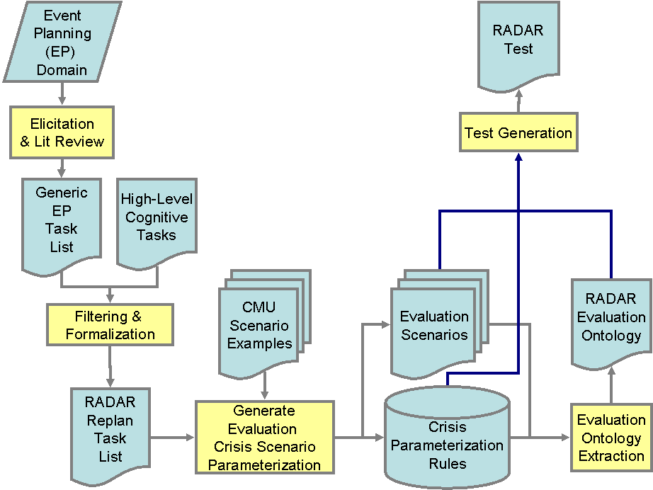
Figure 8 RADAR Evaluation Materials Generation Overview
Short descriptions of each element of the flow diagram are offered in the tables below, with the data and documents in one table, processes in the other. Where appropriate, a pointer to a more detailed discussion is provided.
Data, Documents or Process | Description | References
Event Planning (EP) Domain | Roles and tasks of event planners and operational concepts they use in performing such tasks. | Section 4.3, Appendix C
Elicitation & Literature Review | The initial survey of available literature on event planning task decompositions, along with interviews of several event planners regarding their actual activities, in order to scope domain.
Generic Event Planning Task List | Hierarchy of EP tasks. Provides broad coverage of the EP domain, before filtering for tasks specific to a non-human cognitive agent. | IET Website
High-Level Cognitive Tasks | A set of high-level cognitive tasks agreed by IET and the Government to be central to the expected capabilities of a cognitive agent, and thus to PAL | IET Website
Filtering and Formalization | Filtering of Generic EP Task List according to relevance to event replanning and to the High-Level Cognitive Tasks important to PAL.
RADAR Replan Task List | Formal task list containing only those tasks from the OA domain having relevance to one or more High-Level Cognitive Task. | (captured in Evaluation Ontology – Section 4.3)
CMU Scenario Examples | CMU has developed an impressive backstory in support of the RADAR evaluations, as well as numerous scenario examples. | 3.2.3
Generate Evaluation Crisis Scenario Parameterization | Development of new evaluation scenarios, targeted to demonstration of LITW and cognitive capabilities. | Section 4.2, Section 4.4
Evaluation Scenarios | A set of four sample evaluation scenarios, including background story and materials and one or more trigger events requiring RADAR to react. Useable in pilot studies. | Appendix E
Crisis Parameterization Rules Repository | A repository of crisis parameterization rules to be used to create evaluation scenarios. | Appendix B
Domain Ontology Extraction | Identification and specification of classes, relations, and individuals covered within the RADAR EP domain. Reuses CMU’s existing ontology(ies) where possible. | Section 4.2.1
RADAR Evaluation Ontology | A domain ontology containing allowable classes and instances for evaluation purposes, providing scope to possible scenarios. | Section 4.3, Appendix C
Test Generation | Generation of RADAR tests from evaluation scenarios, domain ontology and crisis parameterization rules. Includes generation of fully-specified scenarios and supporting materials such as relevant documents, emails, and schedule inputs. Test generation also involves checking that the test is sufficient to evaluate learning and RADAR’s cognitive capabilities. | Section 4
RADAR Test | A RADAR test consists of a major crisis, several perturbations, background tasks, and “noise” events. | 4.5 Section
Table 3 Evaluation Materials – Data, Documents, and Processes
Below we describe each of the IET-produced artifacts in greater detail and reference the relevant appendices for access to the artifacts themselves.

Evaluation Scenarios
In order to motivate the human subjects and provide a context in which they perform various tasks, evaluation scenarios will be used through the RADAR evaluations. At the center of the scenarios is an already planned conference, to be held immanently on the campus of CMU. The conference has roughly 200 attendees and four days of papers, demos, and related events.
The test subjects will be stepping into the role of event planner a few days before the conference is supposed to take place. The original event planner will not be available but all of the planner’s files (such as current conference plan in STP native format or prior briefings in Briefing Maker format) and emails will be made available to the test subject. These materials comprise the backstory that will be held constant throughout future RADAR evaluations.
The subject is not expected to have any special knowledge related to the theme of the conference, topics of the papers, or qualifications of the various speakers. Each human subject will be given training on the fundamentals of good event planning. This training will be identical across all test conditions.
The evaluation scenario will be rooted in the previously planned event, with its schedule and speaker plans. The evaluation begins with the introduction, via email, of a major crisis that forces the event to be replanned. This replanning must occur within a very short time period. The major crisis is one problem with widespread ramifications, such as the loss of the main conference location, which then requires the various sessions to be moved out to other buildings on campus. There will be one major crisis per evaluation (i.e., the major crisis will motivate the event replanning across all three sessions during which the test subject is at a work station). Each program year a novel major crisis will be introduced.
A different major crisis will be used each program year. These crises will be unknown to the RADAR development and internal testing teams, so that there is no opportunity to fit development to a specific crisis, even unconsciously.
In addition to the single major crisis, perturbations will be introduced during the course of an evaluation session. These will be injected problems or new constraints. A requirement for perturbations is that the effect of ignoring the perturbation is not exceedingly large in terms of the difference in the score one would receive if the perturbation was never introduced versus the score one would receive if the perturbation was present but ignored. Perturbations will serve the purpose of motivating continued attention to incoming communications. The number of perturbations required during evaluation sessions will guided by experience gained during early pilot tests.
As discussed elsewhere, subjects will also be exposed to background tasks unrelated to the event replanning tasks and noise events. This will have the effect of creating prioritization challenges for the subjects.
The evaluation ontology (Section 4.3) and the crisis parameterization (Section 4.4) developed with CMU inform and constrain the development of scenarios (both the major crisis and the perturbations). Appendix E contains examples of scenario narratives that will be built out to be evaluation scenarios with supporting emails, background tasks, and noise events.

Background Knowledge
As mentioned above, background knowledge assumed and relevant to the RADAR evaluation is specified via the backstory, ontology and crisis parameterization. Information in the ontology and scenario variability specified in the crisis parameterization are fair ground with respect to the creation of evaluation scenarios (i.e., mature systems will have the relevant background knowledge required to reason about such things). Also, any other object types, processes, individual, attributes or data types that exist in the evaluation domain ontology (i.e., in CMU ontologies plus additions suggested by IET, or which are added as part of the ontology updating process) should be treated as presumed background knowledge. Of course, it is quite possible that much of the knowledge gained during RADAR's learning activities will cover this domain knowledge (i.e., we are not suggesting or requiring that any or all of this knowledge be encoded prior to the evaluation).
The ontology and the parameterization specification serve to ensure that there will be not be task requiring a knowledge of DNA replication (relevant to a very distant domain) or calculation of refund amounts (potentially relevant in the EP domain) in the evaluation because such topics are not present in the ontology or changeable given the parameterization specification.
Further background information consists of any contextual information about the scenario conference and environment of the sort contained in the backstory prepared by CMU. It includes the identification of people, organizations, equipment, and other entities in the environment. It also includes which roles entities play in which organizations and events, their type (i.e., professor, staff member) and/or relation to the event (i.e., a major University donor or family member of someone being honored at the event). Thus EngineeringTestRADARs, as well as LearningTestRADARs, have access to this background knowledge.

Evaluation Ontology
The IET evaluation ontology is based on an analysis of the relevant elements and relationships salient to the evaluation domain, – i.e., those to be used in crisis and materials generation, coverage analysis, and scoring in the domain of conference crisis replanning. As such, it plays three important roles. It is used to define scoring processes and procedures, see Appendix D Section 3.2.6. It provides a way to specify the range and breadth of crises introduced and thus plays a critical role in assurance of comparable difficulty between evaluations and in avoidance of performance ceilings (i.e., maintenance of headroom), Section 4.5. Finally, the scoping of the evaluation domain via crisis parameterization, as described in Section 4.4, is most clear and effective when based on such an analysis.

CMU has developed its own ontology, as a means of integrating the concepts utilized by all RADAR components, and we have reused portions of CMU’s ontology where appropriate. The two ontologies are different, in that CMU’s aims to incorporate every detailed input or output concept with the RADAR system, whereas the Evaluation Ontology focuses on the evaluation considerations mentioned above. Nevertheless, there is substantial overlap between the two ontologies, and within that overlap, IET and CMU have worked together to ensure consistency. We have represented the Evaluation Ontology in the OWL ontology language to facilitate sharing and to exploit existing tools for editing and querying.

The RADAR Evaluation Ontology is provided in Appendix C in HTML format to facilitate readability. The full ontology is available, in OWL format, from [give our website and the URL]. It can be viewed graphically using Protégé with the OWL Plugin. This software is open-source, and may be downloaded from http://protege.stanford.edu/plugins/owl/index.html.

Crisis Parameterization
Given the multitude of considerations against a wide-open crisis domain, some specification of the nature and scope evaluation crises is needed. The crises cannot be too particularly specified, however, as overfitting may result.
Crisis Parameterization provides a way to articulate the scope of the nature and difficulty of evaluations, on the one hand, without generating over-fitting, distraction, performance ceilings, or other unwanted side-effects. The introduction of the crisis, as described above, amounts in part to a sudden change to conditions that had been specified in the backstory. Both the replanning process and further email coming in during that process may change the situation further. Parameterization consists of identifying all of the elements of the situation with which we are concerned and specifying whether and how they may be altered, either in the nature of a crisis itself, or in subsequent event. This puts a scope on the nature and difficulty of evaluations, while leaving considerable room for variation and crisis novelty.
IET and CMU have negotiated and co-developed the RADAR Evaluation Crisis Parameterization presented here. The CMU RADAR team has brought for consideration their knowledge of what RADAR can do now and what they expect it to be able to do by Year 5, as well as the feasibility and ramifications of any unplanned capabilities that may be required, by design or otherwise, by potential types of crisis challenges. IET has brought a focus on PAL program-level requirements and desiderata; analysis of domain tasks, system capabilities, and situational elements independent of how they are treated by RADAR; and experience in parameterization of experiment elements. Below we provide a general outline of the types of crisis elements that are parameterized, and of the dimensions of parameterization. The full, detailed Crisis Parameterization is presented in Appendix B.

Sample of Element Types and Properties
The following types of elements and the accompanying primary properties of such elements are among those whose change parameters are specified in the RADAR Evaluation Crisis Parameterization Appendix B.

- Gatherings (talks, parties, meetings. . .)
  - Gathering type: e.g., Keynote session, concurrent technical talk, social gathering, exhibit, organizational gathering.
  - Service and equipment requirements such as catering, setup, projectors.
  - Location requirements such as capacity, room configuration.
  - People: required key (speaker, session chair) or assistant personnel, expected participants.
- Locations (rooms, buildings . . . )
  - Size: specific dimensions, capacity.
  - Possible configurations and set-up costs
  - Use costs
  - Controlling agent
  - Built-in and other stationary equipment
  - Moveable equipment
  - Distances between locations
- People
  - Status: e.g. attendee, VIP, speaker.
  - Group membership (e.g., technical committee)
  - Travel status (e.g., local)
  - Contact info
  - Availability / Schedule
  - Preferences and restrictions (e.g., dietary, accessibility)
- Groups
  - Membership
  - Meetings
- Resources (equipment, services)
  - Vendors, Prices, and Availability
  - Parts, Requirements for use
- Vendors (commercial or university)
  - Resource types offered and Prices
  - Availability
  - Competitive or Monopoly (e.g., only permitted source for university)
- Requirements and preferences (decisions made by or imposed upon the conference planner, requests by participants, expectations regarding events)
  - Hard constraints
  - Preferences
- Communications (emails, possibly including reports of other exchanges, web site updates, briefings, confirmations, other conference related document updates)
- Documents
  - Schedules (for conference as a whole or particular events)
  - Budgets (for conference as a whole or particular events)
  - Plans (for conference as a whole or particular events)
  - Briefings
  - Webpages
  - Hardcopies
  - Digital copies

Changes to any of these elements may be specified to be permitted, not permitted, or restricted in specific ways. In addition, changes to the backstory materials, made before the start of testing, are distinguished from changes brought on by the introduction of a crisis or perturbation.

The following parameters may be specified for particular element types and their properties, once for changes within the backstory and again for changes brought about by crisis or perturbation:

- Whether or not they may be changed at all
- Whether Cardinality must be the same as in the backstory and original plan. That is, number of instances, where instances may mean:
  - The number of individuals who are instances of a particular class, or
  - The number of individuals that stand in a particular relation to each instance of a class (e.g., number of rooms such that availableRoom holds, for each event)
- Whether instances may be added or deleted
- An absolute minimum number of instances that must exist
- An absolute maximum number of instance that must exist
- Any additional steps that must be taken to maintain consistency if a change is made
- Whether or not changes require additional pilot testing to determine impact on human subjects or system functions.

The above outline of element types and parameters is general. Appendix B provides detailed specification of the crisis parameterization developed by IET and CMU.

Test Generation Process – Coverage and Consistency Analysis
IET will perform two general types of data analysis, one before testing and one after testing. Prior to testing, generated scenarios will be examined to make sure that the major crisis and perturbations obey the crisis parameterization rules, and allow for depth and breadth of coverage related to the central program interests in LITW and cognition. After testing, experiment data will be analyzed in terms of evidence for or against the evaluation hypothesis (Section 5).
Breadth and depth of coverage of the tests are essential to meet the evaluation requirements, as provided by the Government.
First, ensuring broad and deep coverage in the event replanning domain mitigates the natural tendency to over fit development to tests, or vice-versa. In order for RADAR to achieve appropriate breadth of coverage (in combination with limited time and resources for development), it requires a certain generality of methods, since it becomes infeasible to hand-craft solutions to all possible event replanning problems. Meanwhile, achieving appropriate depth of coverage strengthens this requirement; the deeper the potential required behaviors, the less feasible it is to hand-craft sufficient solutions.
Second, since breadth and depth of coverage are critical measures of the nature and difficulty of any particular test, these measures must be held consistent over program years. In order to avoid over fitting, new scenarios within the defined evaluation domain must be generated for subsequent years of the PAL program. The evaluation domain, via the ontology, is defined at a level of generality beyond the scope of any single evaluation, in part to make it possible to generate many new, significantly different scenarios (as well as to avoid over-fitting). However, the use of different scenarios inevitably raises the possibility of variations in difficulty between evaluations, variations that could render year-to-year comparison impossible. Breadth and depth of coverage are manageable, measurable elements of difficulty that give us the means to control for such variation.
Adequate evaluation of RADAR systems, therefore, requires measurement and control of the breadth and depth of coverage required by each evaluation. Accordingly, IET will analyze each generated test for compliance with the crisis parameterization rules and coverage of RADAR ontology. This analysis will be used to maintain consistent difficulty of tests across the program years.

Results Analysis

Analysis Overview
In order for the RADAR evaluations to be of maximal use, results will be released to the Government and the contractor on a rolling basis. In Figure 9 we show an overview of the results analysis process.

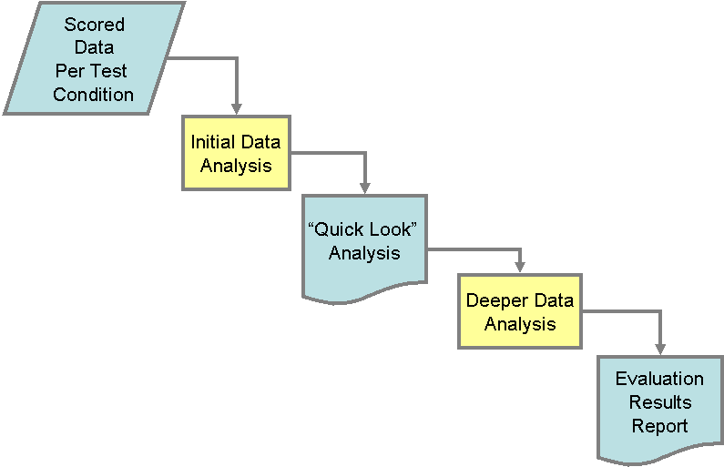
Figure 9 Results Analysis Overview
As performance data is generated (at the completion of the four sessions), it will be scored and a Quick Look analysis will be released, showing performance scores by each subject in a test condition on the evaluation. At the end of the evaluation cycle or program year, a report will be produced providing an overview of performance during the entire evaluation cycle, analyzing performance improvements within development cycles and across program years where possible.
Short descriptions of each element of the flow diagram are offered in the tables below, with the data and documents in one table, processes in the other. Where appropriate, a pointer to a more detailed discussion is provided.

Data, Document or Process | Description | References
Scored Performance Data | Pre-analysis results of automated scoring, for each subject, in all test conditions | Section 3.2.7
Initial Data Analysis | Basic analysis of scores within and between test conditions | Section 5.1.2
“Quick Look” Analysis | Average/Mean scores for data sets from a single evaluation; Changes from previous evaluation. | Section 5.1.1
Deeper Data Analysis | Analysis of variance; assessment of confirmation or disconfirmation of evaluation hypothesis. | Section 5.1.2
Evaluation Results Report | Assessment of the results of a year’s worth of testing, particularly as it relates to the evaluation hypothesis. | Section 5.1.2
Table 4 Data Analysis -- Data and Documents

Measures of Performance
The central performance measure is the value of “OverallScore” (OS) as described in Section 3.2.6 and Appendix D. The scoring process used lends itself to decomposition and it will be straightforward to also generate performance measures for any of the factors that contribute to the overall score including, schedule quality, schedule quality normalized by cost, communication updates, and background tasks. If we require very early analyses concerning the power of the test, it may be necessary to base power analyses on schedule quality alone or schedule quality combined with background task scores as the other factors will depend on human scoring procedures. However, the central performance measure reported to the Government will be the overall performance measure.

Intra-System Yearly Comparison
IET expects to see improvement over time during each evaluation period. Test Condition (TC) performance will be compared year-to-year.
Δ_{IntraSystem-TC1} = Year_{N} OS _{TC1} – Year_{N-1} OS _{TC1}

Δ_{IntraSystem-TC2} = Year_{N} OS _{TC2} – Year_{N-1} OS _{TC2}

Δ_{IntraSystem-TC3} = Year_{N} OS _{TC3} – Year_{N-1} OS _{TC3}

Δ_{IntraSystem-TC4} = Year_{N} OS _{TC4} – Year_{N-1} OS _{TC4}
In order to allow for continuous system development with no need to roll back to a baseline version of the RADAR system or conventional office tools, the delta between the performance scores will be measured, as shown above and in Figure 10, and used to calibrate the performance improvement scores.
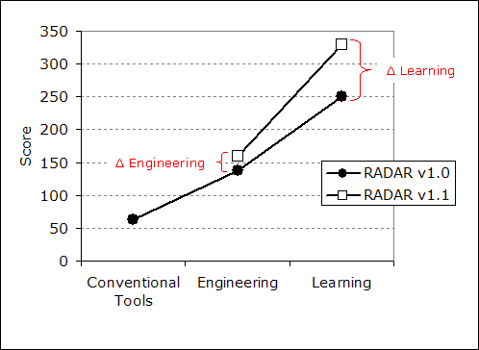
Figure 10 Performance Deltas across Versions
The numbers used for the score are far less relevant than whether there are positive deltas in scores across versions and across program years. It is expected that a greater increase in the delta for the “with learning” condition (TC2) will occur than for the other test conditions.

Learning measurements
For each evaluation period, IET will make comparisons between the average OS for the participants in each test conditions. To the extent that learning is core to the PAL program, Δ_{TC2-TC1} below, is a score in which we’ll be most interested. However, Δ_{TC2-TC3} is also a very important score in terms of demonstrating the overall effectiveness of a RADAR system.
The comparisons include:

- Learning compared to Engineering (Hypothesis 1):

Δ_{TC2-TC1} = OS_{TC2} – OS_{TC1}

- Learning compared to Human using Conventional Tools (Hypothesis2):

Δ_{TC2-TC3} = OS_{TC2} – OS_{TC3}

- Learning compared to Two Humans using Conventional Tools (Hypothesis 3):

Δ_{TC2-TC4-raw} = OS_{TC2} – OS_{TC4}

These comparisons are intended to tease out the contribution of learning and to validate the evaluation hypotheses.

Post-test Analysis of Evidence
The results of the annual experiment will be evaluated primarily by analysis of variance. The factors are:
- Individual Subjects with systems in one of the four test conditions (as we expect individual differences between subjects);
- Performance of subject cohorts in each of the four test conditions (as we expect there to be meaningful differences between test conditions).
Confirmation of the evaluation hypothesis will be provided by comparing the performance achieved across the four test conditions, assuming that variance between subjects is within tolerance compared to variance in observed performance across the four test conditions.
IET will also work with Paul Cohen and Geof Givens to perform further data analysis concerning performance on different components of the evaluation. These analyses will be more effective if extra user and experiment data, as mentioned in Section 3.3.5, is made available.

Data Analysis Concerns
The main concern associated with data analysis is ensuring that there is a sufficient data to establish the hypotheses, should they prove to be demonstrable. Pilot studies will be used to gauge how many subjects are required in each test condition – the goal will be to have variance between test conditions outweigh variance between subjects. We will attempt to control variance by giving all test subjects the same training on event replanning and comparable training on the various tools to be used.
Given the large number of factors that can vary scenario to scenario, there are concerns that the space of possible crises and perturbations is being dramatically under-sampled. A possible side effect of this undersampling is that RADAR might have a set of problems for which it provides tremendous assistance, and which happen not to occur in any test cases. CMU will be conducted smaller, more component based experiments and the results of such experiments ought to assist in identifying undersampled areas of the problem space that are likely to demonstrate RADAR’s capabilities as a PAL.
There are also many other opportunities for research into cognitive systems that arise naturally from these evaluations. IET recommends that some of these opportunities be exploited during the course of the evaluation, while recognizing that doing so may require additional instrumentation efforts by CMU. For one, in addition to testing RADAR’s ability to assist a subject with event replanning, we might attempt to study other factors about the nature and use of RADAR. These include user interaction data, knowledge amounts, change and use and knowledge base volume and change data as well as knowledge sources, and data about how knowledge is used in reasoning.

Data Analysis Recommendations
IET recommends that in addition to analyzing scores, data about user interaction, knowledge volume, knowledge reuse, knowledge implementation and knowledge sources is collected. In particular, it would be helpful to introduce data about user interaction as another factor in the experiment. This could allow a deeper insight as to whether reasoning challenges or usability challenges are hindering RADAR development.

The BEP is available from IET by request.
LITW is defined as learning done by a system without benefit of code updates, revisions or additions by engineers. A system can be said to have the capability to learn in the wild if it can accomplish tasks based on information acquired during regular use as opposed to implementing hard-coded routines.
Some interest has been expressed in videotaping the test subjects’ interactions with the various RADAR system tools. Due to human subjects testing restrictions, this may not be possible but computer instrumentation can be expanded to collect more data.
This section is taken from documents produced by CMU. Thanks to Aaron Steinfeld.
W. Edwards & J. Newman, Multiattribute Evaluation, Sage, Beverly Hills, CA, 1982.
T.L. Saaty, The Analytic Hierarchy Process, McGraw-Hill, Inc., 1980.
We use the language of tree structures here although the diagrams reverse the direction of the edges in the tree to indicate the fact that the “children” nodes are inputs into the “parent” nodes.
We define ‘budget’ here as roughly the minimal amount that a subject would require to create an adequate schedule, it may therefore differ from the budget amount of money or requests that schedules are presented with during the evaluation.
For example, an exhibitor could request a briefing from the event planner, the keynote speaker might request roses for her podium, or a room to be used for a popular talk is discovered to be smaller than previously thought.
These emails will include such things as invitations to symposiums unrelated to the subject’s work and notification of various happenings around campus.
Dr. Givens is a member of IET’s Evaluation Development Group (EDG) and is a professor of statistics at Colorado State University.

