Paper Title

First author’s name  Affiliation  e-mail address | Second author’s name  Affiliation  e-mail address
Third author’s name
Affiliation
e-mail address

ABSTRACT
Under 150 words.

Keywords
Photography, geology, schist, tectonics, Connecticut

INTRODUCTION
This is the template, version 1. We suggest you download this .doc file and edit it to create your document. You can use the styles defined here (Normal, Heading, Bullet, Table Text, References, Title, Author, Affiliation).

FORMATTING
Should look roughly like what’s shown here. Put your paper title in the header. Links to external media such as http://www.panoramas.dk/2009/lake-annecy-paragliding.html are welcome.

SECTIONS
Look like this.

Subsections
Look like this.

Sub-subsections
Look like this.

FIGURES
Look like the below.

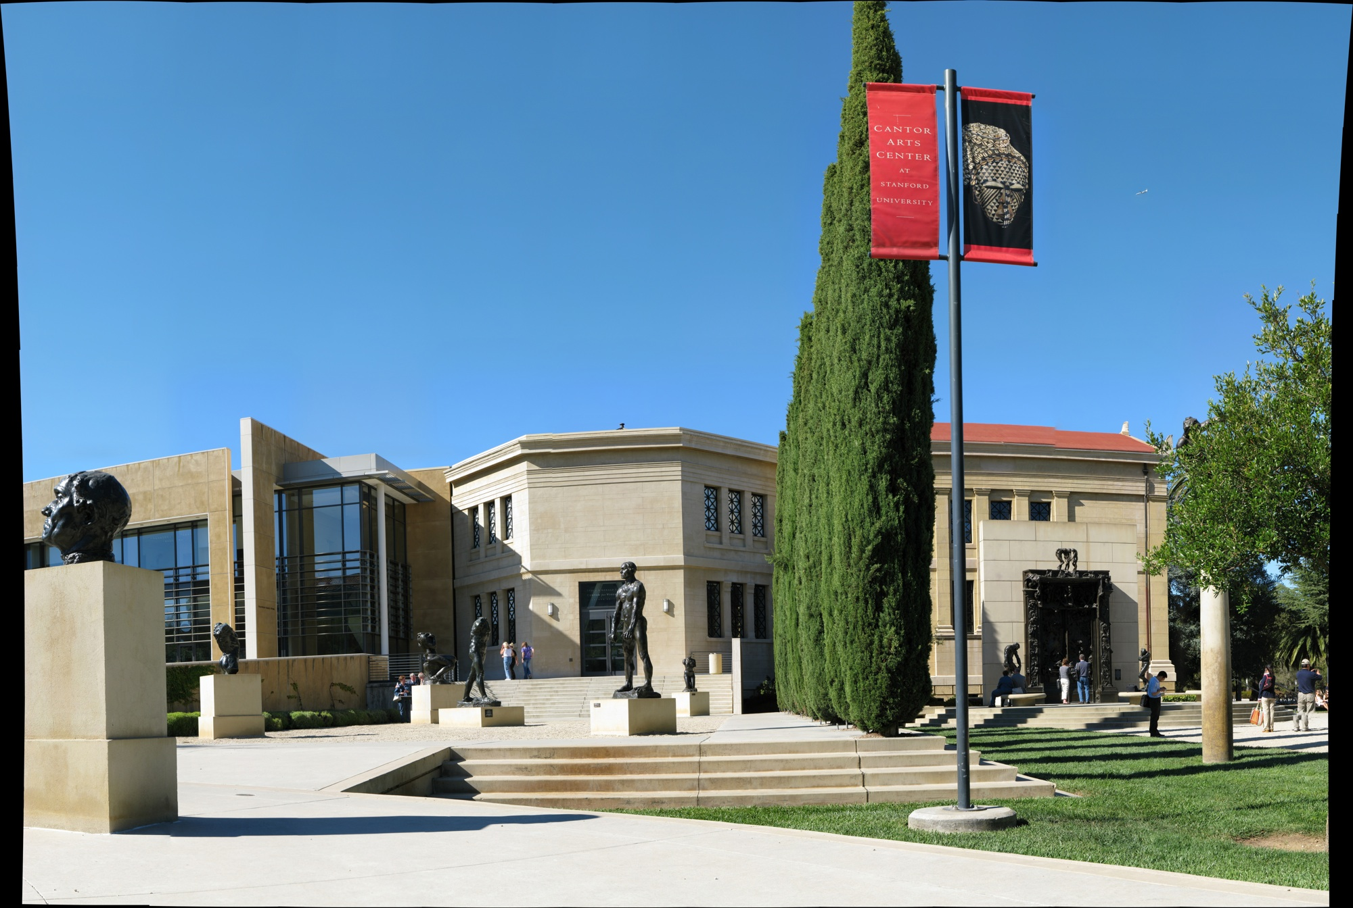
Figure 1. Rodin Sculpture Garden. For zoomable version, see http://gigapan.org/gigapans/506/ .


Figure 2. A snapshot showing detail. For more detail, see http://gigapan.org/gigapans/506/snapshots/144342/ .
Note: to include a link to a gigapan.org snapshot like the one above, on Windows or Mac, go to the gigapan with a web browser, hover cursor over the snapshot of interest, (snapshot text should appear at right), move cursor down below bottom of the row of snapshots, then right to edge of browser window, then up and click on “Add a comment”. On the new web page that appears, click on the snapshot, and it will take you to a page with a URL of the form http://gigapan.org/gigapans/gigapan_id/snapshots/snapshot_id/ that you can cut & paste. Use “Insert … Hyperlink” in MS Word if necessary to convert the URL text into a link.

Conclusion
See the guidelines at the conference call for submissions!

REFERENCES
- Agarwal, R. and Karahanna, E. (2000) Time flies when you're having fun: Cognitive absorption and beliefs about information technology usage, MIS Quarterly, 24, 4, 665-694.
- Ajzen, I. (1988) Attitudes, personality, and behavior, The Dorsey Press, Chicago.
- Tractinsky, N. (1997) Aesthetics and apparent usability: Empirically assessing cultural and methodological issues, in Steve Pemberton (Ed.) Proceedings of the SIGCHI conference on Human factors in computing systems (CHI 97), March 22 27, Atlanta, GA, USA, ACM Press, 115-122. http://www.sigchi.org/chi97/proceedings/paper/nt.htm

