Class 9 --

Example of pitch behavior, as determined by context (scale)

This example includes two chord progressions, marked A and B.
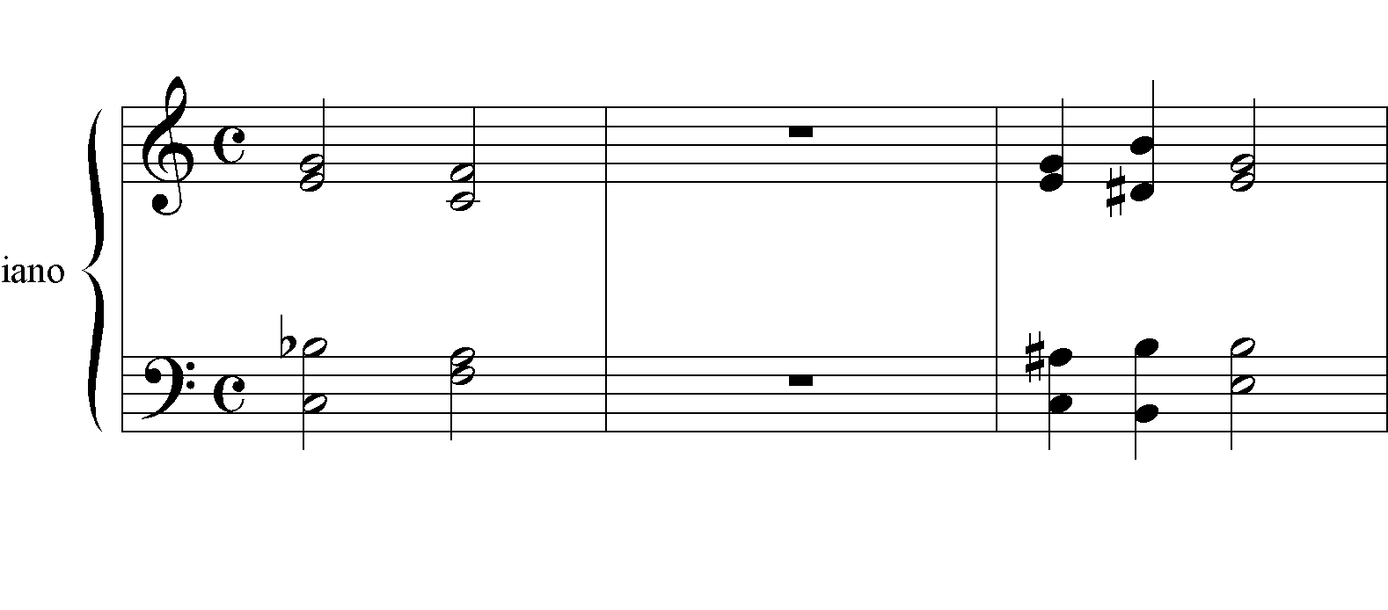
As you can see the first chord C7 in A is a Dominant7 chord, going to I.
Chord progression B starts with the same chord – in terms of music pitch-classes.
But, the chord is interpreted as a German 5/6 (degree IV) in the E major or the E
Minor scales. Therefore it is resolved to the dominant chord, with the B# functioning as a leading note to the dominance.

A. B.

