Locomotion
in
Challenging Environments

Research Paper
for
16-761
Introduction to Mobile Robotics
Spring, 2001

February 8, 2001

Yuzo Ishida

Affiliation:
Master of Software Engineering
School of Computer Science
Master of Business Administration
Graduate School of Industrial Administration
Carnegie Mellon University

yuzo@cs.cmu.edu
Abstraction

Exploring and monitoring in challenging environment is quite dangerous for human being. Some tragedies happened many times in dangerous area such as volcano. Robots can be great help for scientists in any area they cannot investigate as they want including deep-ocean, disaster happened place, and battle fields. After investigation of many articles regarding robotics in challenging environment, the trend in this field was found. Especially in space area, today’s robot in challenging environment is moving toward to the autonomous and vehicle type robots. Legged robots seemed to have bright feature in space exploration but vehicle type robot with autonomous intelligence will be used for at least next 3-5 years under NASA’s space missions. This paper lists type of robots in a variety of challenging environment, challenges and some solutions for them. In general, there are three major challenges to concur; path planning, robot-to-operator interface and motion control in robotics of challenging environment. And all challenges are necessary to achieve a full-autonomous robot.

Introduction

What do you image hearing “robotics in challenging environment”? I believe many people pick up space, dessert, deep sea, polar area, and battlefields. These areas are extremely dangerous or unreachable place for most of us. If a machine with some sense of intelligence can identify problems and solve them by self, this will be significant help for human beings. But dreams won’t come true without significant and continuous efforts. There is one book written in 1960 in my hand. Surprisingly enough, the latest research papers and reports in the most technically advanced application of science and engineering still refer this “old” book. Now I want to look for the link between old but new exciting topic, “locomotion/robotics in challenging environment”.

Systems

There are many types of challenging environment and different types of systems are used in different environment. Before investing robots in challenging environment, I would like to go back to a system in pre-robot area.

1. Space (Moon, Mars)

Lunar Roving Vehicle (LRV)

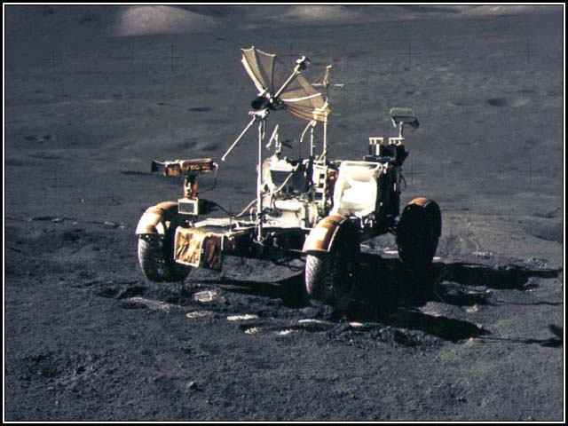

The four-wheel, lightweight vehicle greatly extended the lunar area that could be explored by humans. The LRV could be operated by an astronaut. [LRV] We could not say that LRV is a robot but a land locomotion, even though it is the most exciting first vehicle in space.

Why do we need robot?
Why do we need robot in challenging environment? Why don’t we drive or control by ourselves? Safety reason (to protect ourselves from dangerous environment) seems to be the biggest one. But also we might rescue other people in the disaster condition such as bombed building.

Ambler

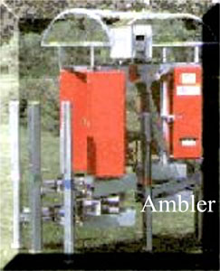
The "Ambler," a six-legged, 12-foot-tall, prototype, autonomous robot with the "brains" and motor skills to explore rugged terrain, is being developed for NASA by Carnegie Mellon University's Robotics Institute. Future operational rovers, based on the Ambler design, could reach areas on the Moon and Mars inaccessible to wheeled vehicles or too dangerous for humans. The Ambler represents an integrated, self-sufficient system that will be used to provide NASA mission managers with the confidence that legged vehicles are a realistic alternative to wheeled rovers for lunar and Mars exploration.(in 1990) [Ambl]

Why vehicle-type robots rather than legged-type robots?
Legged robots are not used for NASA’s space explore missions.
I believe that six-legged robots are very stable to move around Mars surfaces, which are not known well and seems to have many rocks or obstacles on its surfaces. Because legged robots have better ability to overcome steep hills than wheeled robots have, the legged robots seemed to be better choice for unknown or challenging terrain such as Mars. But vision technology provided “insight” robots to understand what there are in front of them. Now they can avoid the obstacle and plan/adjust their path by themselves. With this additional new ability, wheel based robots becomes to be more attractive choice for the challenging environment, because basically they can move faster and more efficiently than legged robots do.

Field Integrated Design & Operations (FIDO) rover

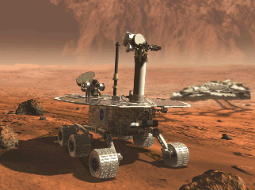

Currently, the FIDO rover directly supports the NASA/JPL Mars Exploration Rover (MER) Project that will launch 2 rovers to Mars in the summer of 2003. FIDO will conduct field trials in 2001 and 2002 to assist with training Mars scientists and operations personnel by allowing these people the opportunity to operate a fully-instrumented rover within challenging geological settings on Earth that are analogous to settings on Mars.

In addition to the support of the MER project, the FIDO rover task looks beyond the 2003 opportunity by developing advanced technologies in the areas of robust surface sampling (rock and soil), autonomous on-board software that reduces the number of interactions with Earth-based mission operators required to complete a science function, surface rendezvous with both natural and man-made objects, along with advanced mission operations capabilities. [Fido]

Are legged-type robots less important than wheeled-type robots?
Now wheeled robots began to elude the market of legged robots but not entirely. There are still remaining important roles for legged robots. I believe that more rough and touch terrain or steep slopes are sanctuary for legged robots such as volcano exploration because wheeled robots cannot move around in such environment because of less traction and less sensitive mobility (Terrain might be so weak or steep that robots have to change a step before putting their weight on the leg).

2. Volcano

Dante

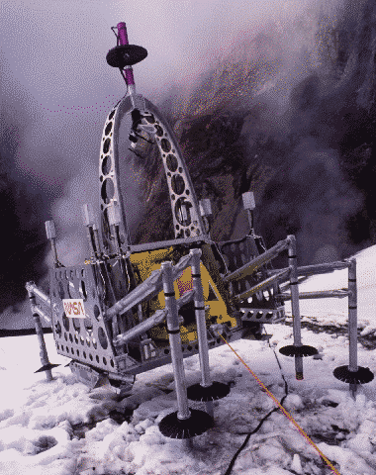

The CMU Field Robotics Center (FRC) developed Dante II, a tethered walking robot, which explored the Mt. Spurr (Aleutian Range, Alaska) volcano in July 1994. High-temperature, fumarole gas samples are prized by volcanic science, yet their sampling poses significant challenge. In 1993, eight volcanologists were killed in two separate events while sampling and monitoring volcanoes. The use of robotic explorers, such as Dante II, opens a new era in field techniques by enabling scientists to remotely conduct research and exploration.

Using its tether cable anchored at the crater rim, Dante II is able to descend down sheer crater walls in a rappelling-like manner to gather and analyze high temperature gasses from the crater floor. In addition to contributing to volcanic science, a primary objective of the Dante II program is to demonstrate robotic exploration of extreme (i.e., harsh, barren, steep) terrains such as those found on planetary surfaces. The Intelligent Mechanisms Group (IMG) has been developing advanced telepresence and virtual environment based operator interfaces since 1991. These advanced interfaces are important for terrestrial science and exploration applications, and are critical for planetary surface missions. During the fall of 1993, the IMG demonstrated the application of such interfaces via field testing of the Telepresence Remotely Operated Vehicle (TROV) under the sea ice near McMurdo Science Station, Antarctica. [Dante]
3.Antarctic

Nomad
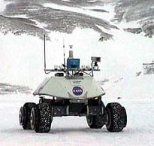

The Robotic Antarctic Meteorite Search at Carnegie Mellon is developing robotic technologies to allow for autonomous search and classification of meteorites in Antarctica. In November 1998, the robot Nomad was deployed in the Patriot Hills region of Antarctica to per-form several demonstrations and experiments of these technologies in a polar environment. Nomad drove 10.3km autonomously in Antarctica under a variety of weather and terrain conditions. [Anta]

What are important aspects for autonomous robots?
The key success criteria for autonomous robots are path planning (obstacles finding), least communication between a robot and a controller and accurate motion control, I believe. Especially when the communication and remote control is difficult, the robots themselves have to be intelligent enough to be able to make right decisions and move as they plan (ex, the distance between Mars and earth is too long to avoid communication delay. Exploration behind mountains on Antarctic from base camp is extremely hard because mountains prevent the communication between robots and base camp. Furthermore, snowstorm plus white terrain produce “white out”).

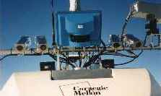
Challenges

Autonomous

The main challenge for robots in challenging environment could be “autonomous”.

Fig 1. Robot capability and categorization
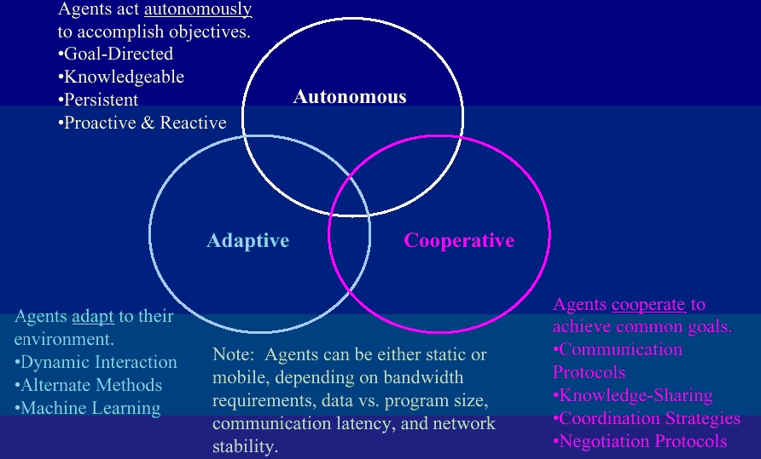
[Lin99]
How do the previous examples fit into these three types?
- I could argue that legged robots climbing obstacles rather than avoiding them are adaptive robots.
- I could say that FIDO rover (JPL) is not completely autonomous because it reduces the interaction with controllers but still cooperate to achieve goals.

Key research area of robotics for challenging environment
- Path planning
  - Vision technology helps autonomous robots very much.
  - By capturing the information on ahead or surroundings of robots accurately, robots can make a plan the best path to move.
  - Snow-storms make invisible even for human vision.
  - Knowing current position of robots (localization) is also critical point for autonomous. Without knowing where we are, we cannot decide the direction.
- Operator interface and supervisory control
  - Full autonomous is almost impossible at this moment.
  - Therefore operator interface and remote control needed to be improved for more efficient ways.

- Control robot and manipulator
  - Terrain might not be hard enough to support weight of robots.
  - Robots have to be able to keep adjusting the difference between the result of motion and the estimation.
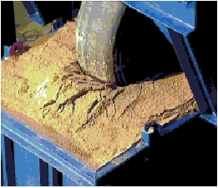
What kind of potential solution do you think?
In my idea, we might utilize another small light child robot, whose purpose is collecting data for its parent, the main body. Sensors can collect and expect information on environment but these are limited and not accurate enough to make right decisions. If the child robot has checking device such as ultrasound sensor and a stick-type sensor knocking terrain to check the hardness, it can inspect both conditions of on and under terrain (Just like skier’s inspection before the race: they know the snow condition on surface and hardness of under the surface). As a result the parent can move further safe area or path.

Solutions

- Path planning (Sensor)

Capture
Antarctica is a challenging environment for autonomous mobile robots and terrain sensing modalities. Stereo vision works poorly or not at all here. The vast majority of the terrain is made up of snow and ice fields which pro-vide little texture for disparity matching. Stereo is further hampered in overcast conditions where the diffuse nature of the light eliminates all contrast, making it difficult even for human vision to work. The laser sensor works well on all terrains but heavy blowing snow reflects the beam causing false readings.

Identify (Localization)
Localization is the process by which a mobile robot or other physical agent keeps track of its position as it moves around an environment. It is an essential capability for autonomous mobile robots if they are to perform tasks in an efficient way: a robot that gets lost in per-forming a delivery is useless. The problem of localization is made difficult because, in general, we are trying to construct robots that can act intelligently in environments that are imperfectly known, and for which their sensors give only uncertain information. This naturally leads to the consideration of probabilistic methods, in which the spatial state of the robot is represented as a probability distribution over the space of possible robot poses (location and direction). The problem of localization is then the problem of updating the distribution, based on robot motion and sensing, given a map of the environment that may be imperfect. A recent approach to this problem called Markov localization (ML) has proven to be both robust and accurate. The key idea of ML is to compute a discrete approximation of a probability distribution over all possible poses. Now a new method for computing Markov localization, which we call correlation-based Markov localization (CBML) is more efficient algorism. Localization based on correlation operations is an efficient alternative to standard ML updating. It is several orders of magnitude faster, and uses corresponding less storage in representing map objects. [Mcorr]

Think
An error recovery module has been added which lets Nomad backup and turn when it is blocked by obstacles or exceeds its roll and pitch specifications. [Anta]

- Operator interface and supervisory control

Ultimately, operator pre-programmed or set configuration before mission starts and do nothing. But at this stage, we have to improve software architecture and interface system to provide less interaction to achieve goals.

- Control robot and manipulator

Less and on-line calculation to estimate terrain parameters required

1) wheel-terrain interaction
An important and often neglected aspect of rover system modeling is wheel-terrain interaction modeling. Wheel-terrain interaction has been shown to play a critical role in rough-terrain mobility. Fundamental research into wheel-terrain interaction mechanics was pioneered by Bekker . Many researchers have studied methods for identifying key wheel-terrain interaction model parameters using off-line estimation using costly, dedicated testing equipment. But on-line estimation is necessary for full autonomous robots.

2) Wheel-terrain contact angles
Wheel-terrain contact angles are another important elements of a rover model (see Figure below). These angles greatly influence rover force application properties. For example, a rover traversing flat, even terrain has very different mobility characteristics than one traversing steep, uneven terrain. Previous researchers have proposed installing multi-axis force sensors at each wheel hub to measure the contact force direction. However, this solution is costly and mechanically complex. A method for contact angle estimation has been proposed based on terrain map knowledge. However, the terrain map is usually not well known. This method is also computationally intensive. We need a method for wheel-terrain contact angle estimation that utilizes simple on-board sensors for autonomous robots.
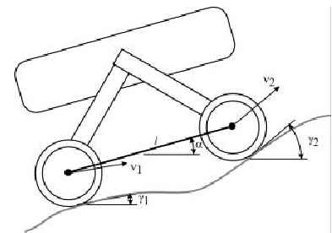[Lang]
Conclusion

After this research, I see the clear trend of “autonomous” in the robotics in “challenging environment”. And also I feel that saying “autonomous” is easy but hard to achieve. Without answering the following questions more accurately, “full autonomous” is impossible:

Where we are: Accurate and efficient algorism for localization
What we see: Robust vision technologies to capture terrain
What we expect: Less/faster and on-line calculation to estimate terrain

Finally, I hope tremendous work by thousands of scientists, engineers, and researchers in this field for the last 40 years since OFF-THE-ROAD LOCOMOTION in 1960 by M.G. Bekker will become great help for everyone and everything on the earth.

Reference:

[Lin99] Linda Cuplin December 7, 1999 ASEN 5519 Final Project
[Anta] Stewart Moorehead, Reid Simmons, Dimitrios Apostolopoulos and William “Red” WhittakerAUTONOMOUS NAVIGATION FIELD RESULTS OF A PLANETARY ANALOG ROBOT IN ANTARCTICA
[Dante] http://img.arc.nasa.gov/Dante/
[LRV] http://www.nasm.edu/apollo/lrv/lrv.htm
[Ambl] http://science.ksc.nasa.gov/shuttle/missions/status/r90-69
[Fido] http://fido.jpl.nasa.gov/
[Mcorr] Robotics perceptionTracking #A595 Markov Localization using Correlation
[Lang] Karl D. Iagnemma: Rough-Terrain Mobile Robot Planning and Control With Application to Planetary Exploration

