Week: 10 Date: 03/28/2024
15-110 Recitation Week 10

Reminders
- How was Exam 2?
- HW5 due Monday 04/01 at Noon.
- Feedback form
Overview
- Meme Cipher Encryption
- RSA
- Top Down Preview

Problems

Meme Cipher Encryption
Carnegie Mellon
surprised
I
good
cool | 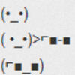
grade | 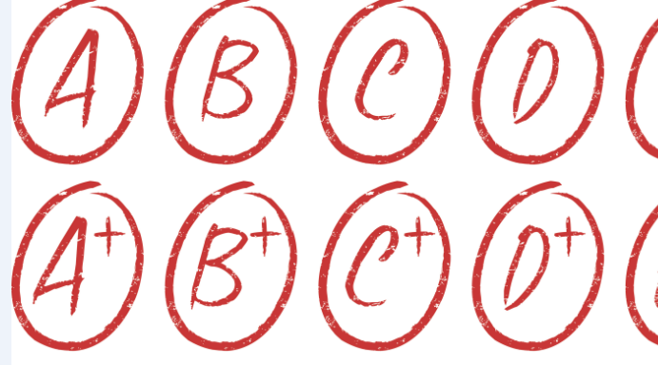
Encrypt:
Carnegie Mellon is cool.

Decrypt:

What is the plaintext? __________________________

What is the ciphertext? _________________________

Is this a symmetric or asymmetric encryption algorithm? _________________________

How many keys are used? _________________________

What is the key? _________________________

What is the runtime to break this cipher? Keep in mind that an adversary knows each meme corresponds to a word, but they don’t know which words are being used in the message. This means they would have to check each possibility in the dictionary. For this question, assume there are N words in the dictionary and 6 memes that are used.

RSA Recap
Krishna wants to send a super secret message to Sean about the 110 exam. She translates the message into a number: 11, and then finds Sean’s public key online. His key is (5, 133).

We create the ciphertext by: _____________

Krishna puts this number on her instagram story, and tags Sean. Why should this not worry Sean or Krishna?

Then Sean sees it and decrypts it with his ______________ (65, 133) by ____________________
Sean gasps!

Top Down Design
Amogh wants to build a game where you try to remove the numbers 2 through 10. The game involves rolling two dice, and summing them. You can then remove a pair of numbers that add up to the number, or that number itself. When you remove all the numbers you win, if you get stuck and can’t remove any numbers you lose. Ex: the first turn I roll a 3 and a 4. I can either remove 7, (5,2), (3,4), etc.

How might we describe the steps needed to make this game in plain english:

I

Now download the starter code. Amogh created a couple helper functions that implement these steps, but he forgot to write the playGame function! Let’s help him out. (First look over the helper functions! What are they doing?)

