Week: 02 Date: 01/25/2024
15-110 Recitation Week 2

Reminders
- Hw1 due Monday 1/29 at Noon!
- Check 1 grades are out! The revision deadline is 2/06
  - Make sure to look at any feedback you got on gradescope!
- For recitation today:
  - There is a starter code file on the website – use that to get some practice running code!
- Recitation feedback form

Overview
- Binary practice, ASCII, RGB
- Functions, arguments, returned value, side effects
- Graphics practice, tkinter

Problems
BINARY PRACTICE

Conversion Practice:
Convert 38 to binary using 8 bits

Convert 101 to binary using 8 bits.

What is 01110111 in decimal?

What is 11010010 in decimal?

What is the next binary number after 0011?

ASCII/RGB Conversion Practice:
What ASCII character corresponds to the decimal value 64?

Convert 1010101 to ASCII.

For a certain color, the RGB value represented as a binary string is: 00101101 01110101 11100111. Convert this to a decimal value for the R, G, and B values of the color.

FUNCTION PRACTICE
Parts of a Function Call:

Libraries Practice + Function Cheat Sheet

Function Reference
Built-in Functions:
- abs(a): takes the absolute value of a
- pow(a, b) : raises a to the power of b
- round(a, b): rounds a to b number of significant digits
Random Library
- random.randint(a, b): randomly chooses an integer on the closed interval [a, b] (a and b are included!)
- random.random(): picks a random float between [0, 1) (1 is excluded!)
Math Library
- math.ceil(a): takes a number and returns the next highest integer
- math.log(a, b): takes the log of a with base b
- math.radians(a): converts degrees to radians

A painter is doing some planning for this year, and is hoping to predict how much paint he’ll need and how much money he’ll make. He’s hoping you’ll help him with your vast knowledge of Python built-in functions, and the math/random libraries.

The painter knows that in general, it rains between 10-15% of days in his area. He asks us to pick a random percentage in this range and calculate the number of days, out of 365, that it rains on. We should round this number of days up to the nearest integer. The painter works every single day that it doesn’t rain, and makes $100 dollars every day. He loses $50 on every day that it rains, since his paint from the previous day is half washed away and he has to redo it. What is the painter’s expected revenue this year?

Built-in Functions, Return Values, and Side Effect Practice
For each of the following function calls, what is the return value and side effect, if any?
Function Call | Returned Value | Side Effect?
abs(-1) | 1 | No side effect
print(“hello”)
print(float(4))
print(“None”)
type(“110 rocks!”)
math.log(16,2)

GRAPHICS PRACTICE
Tkinter review
Follow along with your TA to draw a robot! At the end we should get something like this:
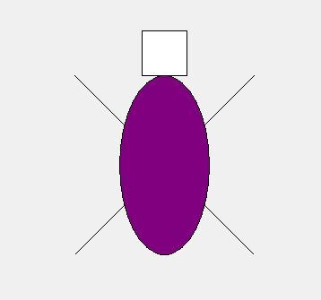

Practice
We’d like you to take the remainder of recitation to practice using tkinter. You can draw anything you’d like but here are a few ideas in case you need some inspiration:
- house, self portrait, your favorite food
Or you can try to improve our robot to something that looks more robotic. Here’s one students robot for inspiration:
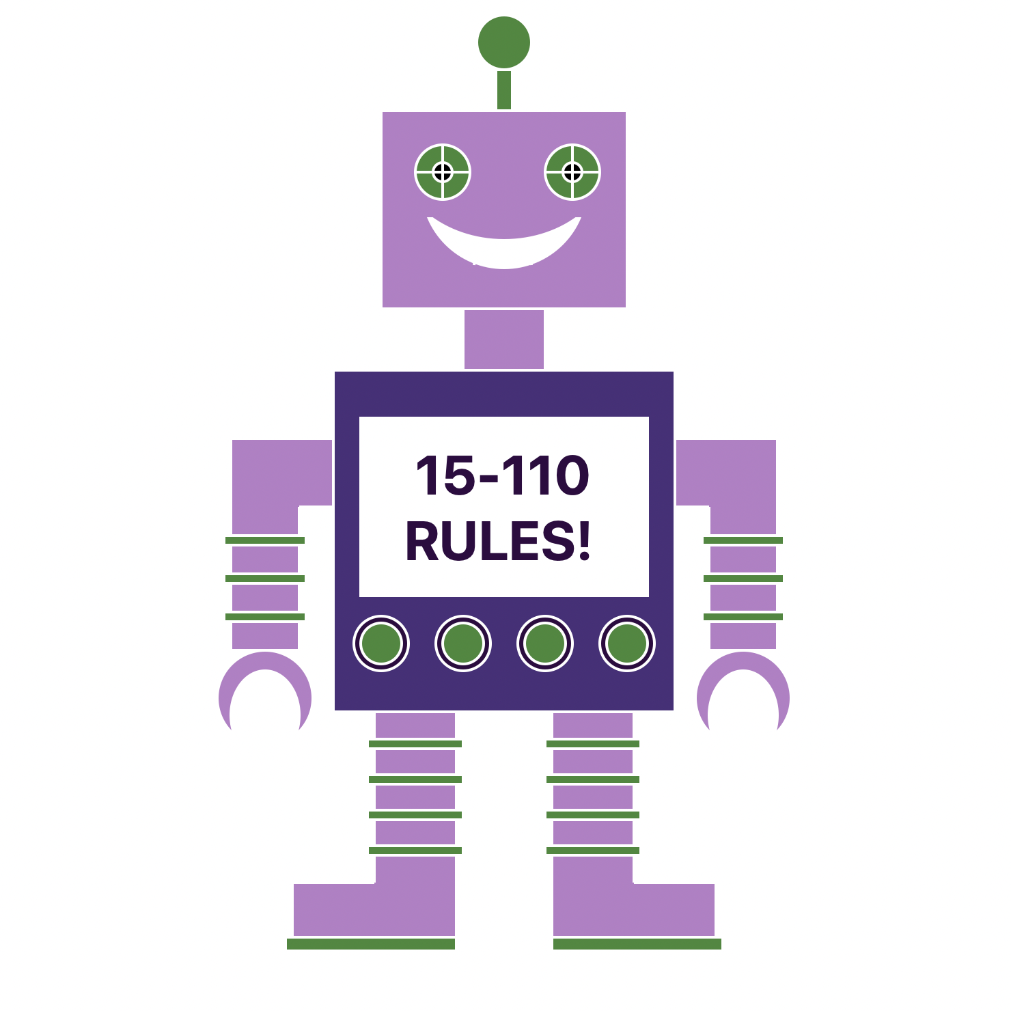

Please ask your TA’s if you have any questions or are having any issues with this on your computer.

