15-104 Introduction to Computing for Creative Practice – FALL 2023

NAME: ENTER YOUR NAME HERE

ANDREW IS: ENTER YOUR ANDREW ID HERE

SECTION: ENTER YOUR SECTION LETTER HERE (A-E)

CONCEPTS QUESTIONS 01

Enter your answers to each of these questions in the space provided. Do not use online tools (including AI tools). Do not consult with other students when answering these questions. The information you fill in should be your work and only your work.

- Consider the 400 X 400 canvas below. Thin black grid lines are given to help you determine coordinates but are not considered part of the final sketch.
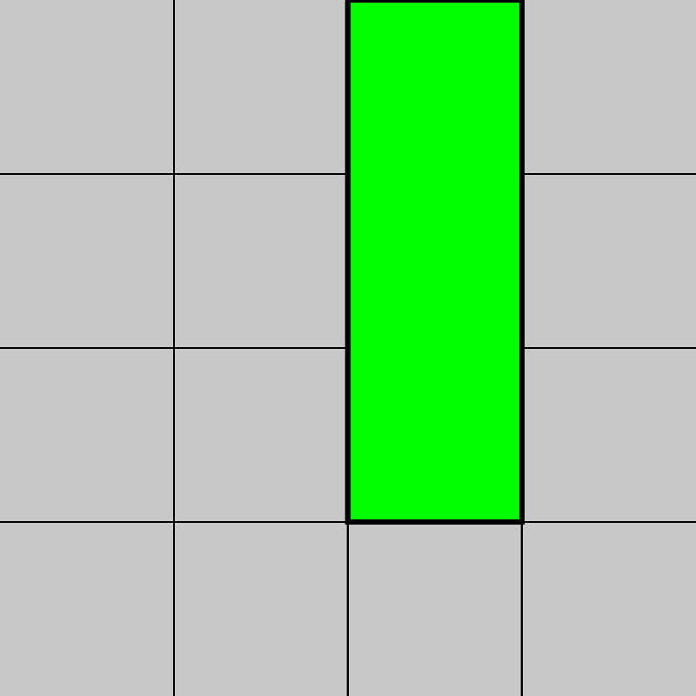
Indicate the numerical values for a, b, c, and d below to draw the sketch above. (All four values must be correct for full credit.)
function setup() {
createCanvas(400, 400);
background(200);
}
function draw() {
strokeWeight(3);
fill(0, 255, 0);
rect(a, b, c, d);
}
a = b = c = d =
- Complete the sequence of p5.js statements in the correct order that will draw the four squares below on a 400 X 400 canvas. Each square is 150 X 150. The reference lines are there only for your guidance to help you determine the relevant coordinates. You do not have to worry about the borders of the squares for this problem, just the colors and the shapes.
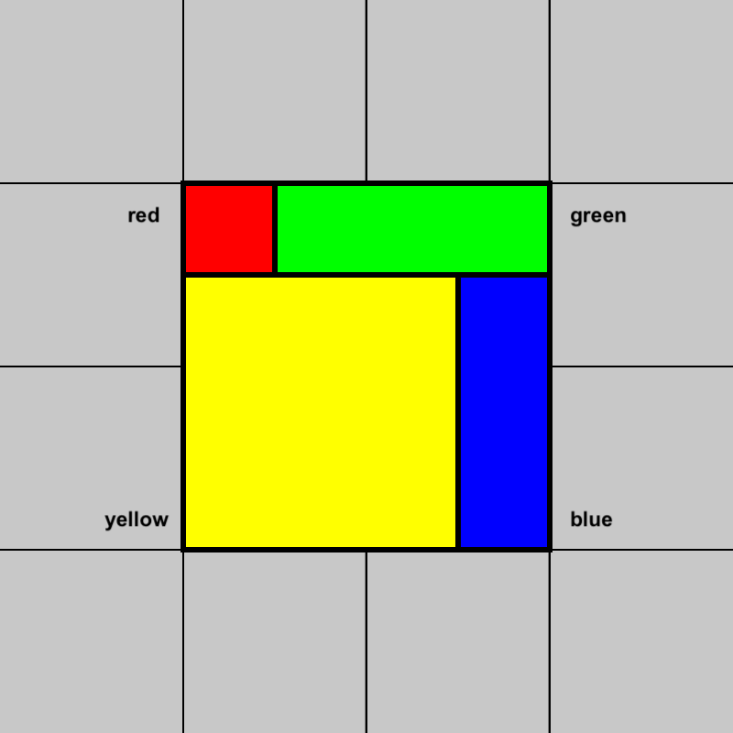
YOUR ANSWER:

- Write a single p5.js instruction (not a whole program) that will draw a circle of diameter 50 in a random location in the top left quadrant of a 500 X 500 canvas, so that the circle remains entirely in the top left quadrant.
YOUR ANSWER:

- Briefly describe in a few sentences what the following program does based on the position of the mouse. Do not just recite the instructions. State what happens when the mouse is on specific parts of the canvas.

function setup() {
createCanvas(600, 400);
}
function draw() {
if (mouseY < (height * 0.5)) {
background(255, 0, 0);
} else {
background(0, 0, 255);
}
YOUR ANSWER:

