15-104 Introduction to Computing for Creative Practice – FALL 2023

NAME: ENTER YOUR NAME HERE

ANDREW ID: ENTER YOUR ANDREW ID HERE

SECTION: ENTER YOUR SECTION LETTER HERE (A-E)

CONCEPTS QUESTIONS 6

Enter your answers to each of these questions in the space provided. Do not use online tools (including AI tools). Do not consult with other students when answering these questions. The information you fill in should be your work and only your work.

- Consider the 400 X 400 canvas below. Thin black lines are given to help you determine coordinates but are not considered part of the final sketch.

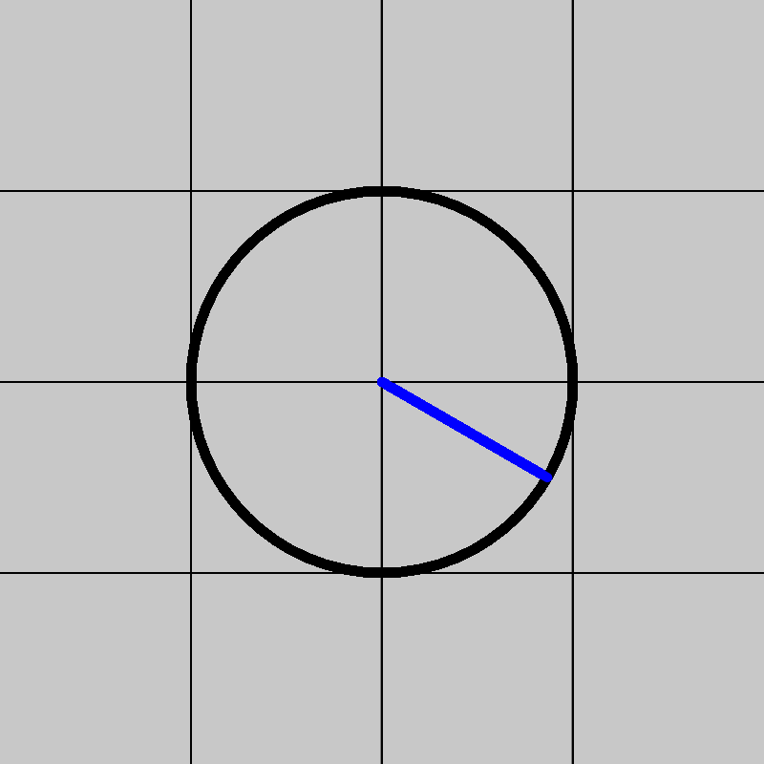
The following function creates the sketch above. What is the missing instruction that draws a line at an angle of 30 degrees from the center of the circle below the center horizontal line?
function draw() {
strokeWeight(5);
translate(200, 200);
noFill();
circle(0, 0, 200);
fill(0, 0, 255);
stroke(0, 0, 255);
// MISSING INSTRUCTION
noLoop();
}
YOUR ANSWER: _______________________________________________________________

- Let temps be a non-empty array of temperatures. The following functions is meant to compute and return the number of temperatures in the array that are above 75. However, it does not work because there are two logical errors where instructions are in the wrong place.
1 function countAbove75(temps) {
2 for (var i = 0; i < temps.length; i++) {
3 var count = 0;
4 if (temps[i] > 75) {
5 count++;
6 }
7 return count;
8 }
9 }
Identify the two instructions that are out of place and indicate where they should be, using the line numbers indicated.

YOUR ANSWER:

- What does the following mystery function return, assuming L is a list?
function mystery(L) {
var M = []; // set M to be an empty list
while (L.length > 0) {
M.unshift(L.shift());
}
return M;
}
YOUR ANSWER:

- Complete the following function that draws an octagon shape centered on a
500 X 500 canvas (as shown in this example on a gray background):
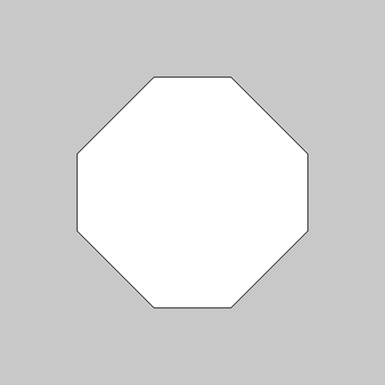
function drawOctagon() {
var x = [ /* MISSING */ ];
var y = [ /* MISSING */ ];
beginShape();
for (var i = 0; i < 8; i++) {
vertex(x[i], y[i]);
}
endShape(CLOSE);
}

YOUR ANSWER:
var x = [ ______________________________________________ ];
var y = [ ______________________________________________ ];

